Digitising sandbox experiments using open-source Structure-from-Motion/photogrammetry package MicMac

Olivier Galland¹, Luc Girod², Sonja H. M. Greiner^{3,4,5}, Pauline Souloumiac⁶, Frank B. B. Guldstrand^{1,7}, Håvard S. Bertelsen², Daniel Yagupsky⁹

Affiliations
¹ The Njord Centre, Department of Geosciences, University of Oslo, Norway
² Department of Geosciences, University of Oslo, Norway
³ Nordic Volcanological Center, Institute of Earth Sciences, University of Iceland, Reykjavík, Iceland
⁴ Department of Earth Sciences, Uppsala University, Uppsala, Sweden
⁵ Center for Natural Hazard and Disaster Science (CNDS), Sweden
⁶ Laboratoire Géosciences et Environnement Cergy, CY Cergy Paris Université, France
⁷ Swedish Defence Research Agency, Sweden
⁸ CONICET-IDEAN, Instituto de Estudios Andinos “Don Pablo Groeber”, Universidad de Buenos Aires, Buenos Aires, Argentina

Appendix D. Method for improving data quality
This appendix describes a method that helps the modeller to improve the quality of the SfM/Photogrammetry calculations.
The aim is to run test calculations, and use some of the output data produced from MicMac. This relevant data is contained in folder output/000/Ori-TGC (see in Figure 2). File Residus.xml provides the values of the residual of the SfM calculation, i.e. the error of the calculation: the lower the residual, the better the calculation result. The bottom lines of file Residus.xml are displayed in Figure 1. The main number of interest is the AverageResidual, which quantifies the overall error of the calculation accounting for all the cameras. Values between 0.3 and 0.5 of this number are very good. In our laboratory, we manage to achieve average residual <0.2, which indicates excellent SfM setup. More specifically, the file Residus.xml also provides the residual values specific to each camera (Figure 1). If a value is significantly higher than the others, it indicates that the calibration of this camera might be poor.
Other helpful files that can help the modeller to assess the quality of the preparation procedure are files CAM_Abs.ply and CorrMap.tif in folder output/000 (Figure 2). File CAM_Abs.ply contains the point cloud of the tie points used for the SfM calculation (Figure 10). A general rule is that too few tie points lead to lower quality of the SfM calculations. File CorrMap.tif is a correlation map and quantifies the robustness of the photogrammetry calculation and the quality of the final DEM results. This correlation map is calculated in the same mask as that of ORT.tif and DEM.tif; file CorrMap.tif and DEM.tif have the same number of pixels. White pixels in the correlation map correspond to high correlation and good data quality; conversely, the darker a pixel, the lower the correlation, and so the quality of the calculation. The aim is to establish a procedure that leads to a CorrMap.tif image that is as white as possible.
In general, the information contained in CAM_Abs.ply and CorrMap.tif help improving the texture of the model surface. Figure 2 illustrates how to use these files to assess the relevance of a texture on the surface of a model made of quartz sand. On the first model surface (Figure 2, top row), the model surface only consists of the bright, fine-grained sand. The corresponding correlation map appears grey, and there is a small number of tie points (3567). The resulting value of the residual is 0.554. This result indicates that MicMac found few tie points on the quartz sand surface to optimize SfM calculations.
On the second model surface (Figure 2, middle row), we sieved high-density texture of grains of instant coffee on one half of the model surface, whereas the other half of the model surface consists of the quartz sand only. The resulting correlation map clearly displays two domains: the domain corresponding to the surface textured with the instant coffee is much brighter that the surface consisting of quartz sand only. In addition, many more tie points were detected (15308), which appear mostly concentrated in the half-surface with the coffee texture on the point cloud (Figure 2, middle row, right). The resulting value of the residual is 0.364, i.e. significantly lower than that of the quartz sand surface. This result indicates that the addition of coffee texture significantly improved both the SfM calculation and the photogrammetry, and so the quality of the DEM data.
Finally, on the third model surface (Figure 2, bottom row), we sieved low-density texture of grains of instant coffee on the half of the former model surface that was made of quartz sand alone. The resulting correlation map shows that the correlation locally improved where the new instant coffee grains where sieved. Even more tie points were detected (17455), which appear more distributed over the model surface than the former on the point cloud (Figure 2, bottom row, right). The resulting value of the residual is 0.371, i.e. similar to the former one.
These results show some correlation between the average residual, the correlation map and the number of tie points: overall, the more the tie points, the better the correlation, and the lower the average correlation. The art of the modeller is to perform the necessary tests to prepare the best model surface texture and implement the best camera calibration to obtain the lowest average residual value as possible. The tips provided in this section intend to help the modeller to adjust the camera calibration and the texture of the model surface to obtain the best results as possible.

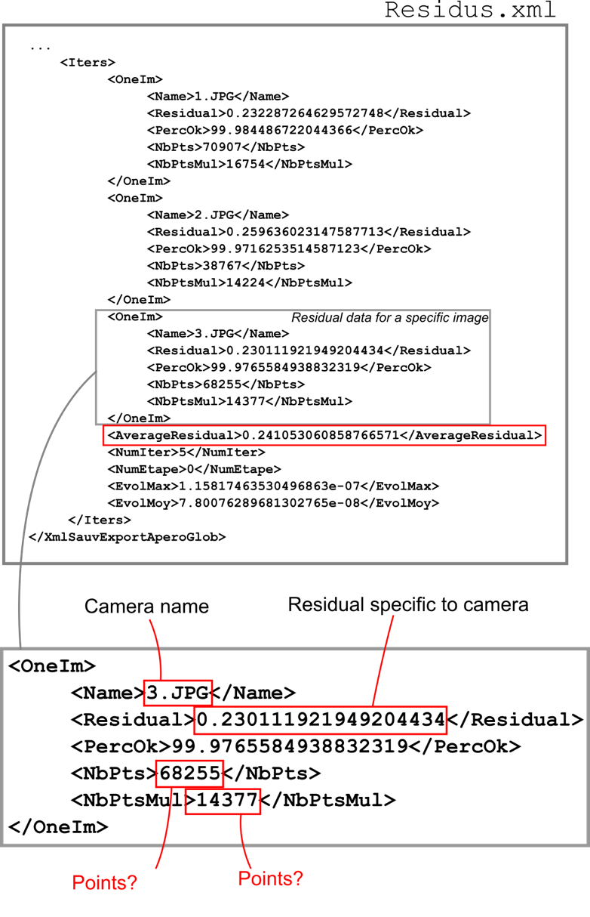
Figure 1. Last lines of example file output/000/Ori-TGC/Residus.xml for a setup with three cameras.

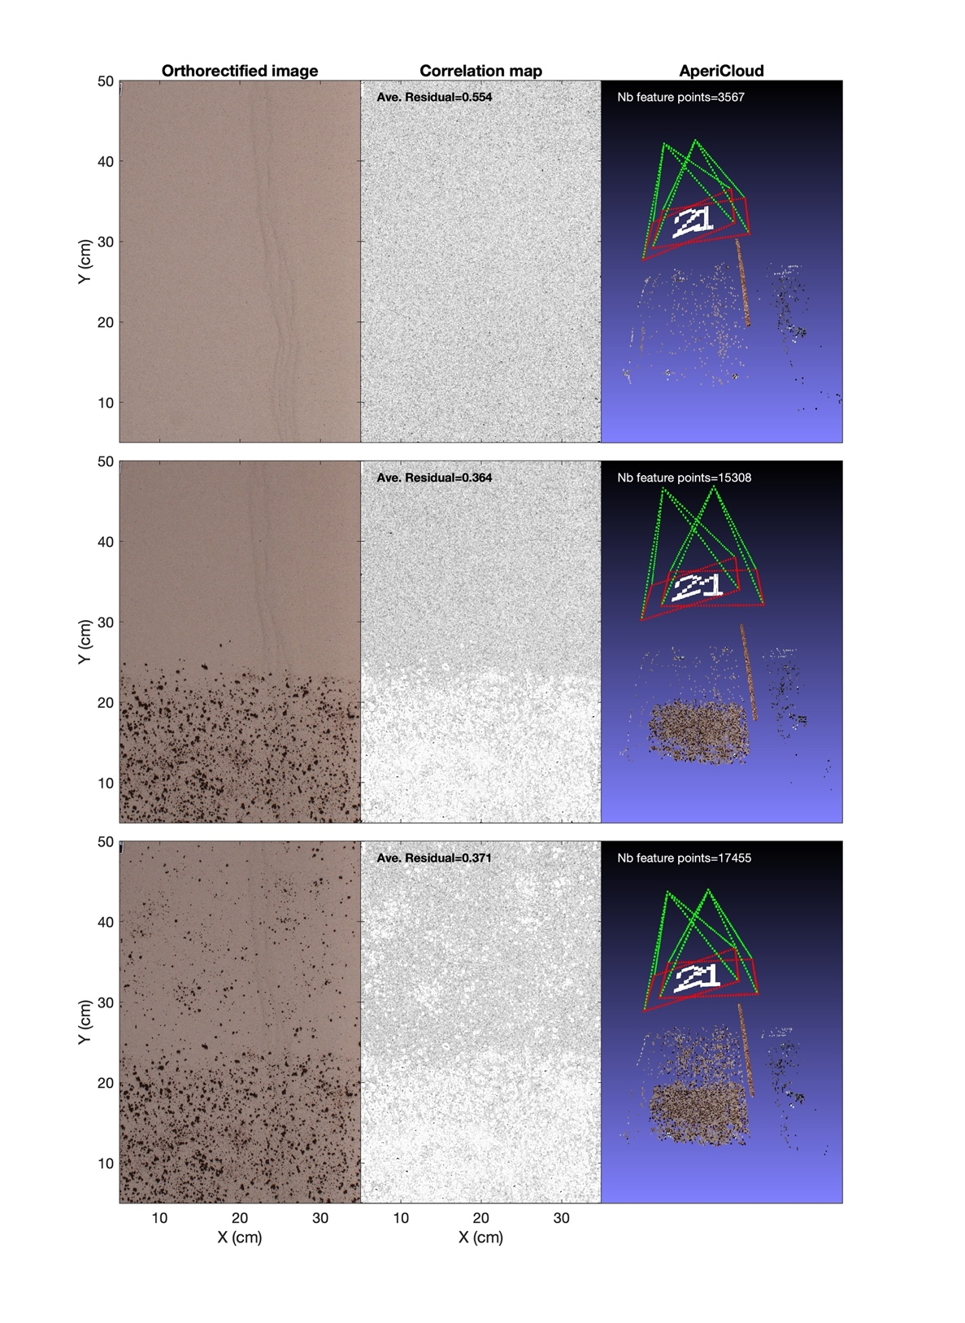
Figure 2. Characteristic results of SfM tests quality depending on texture on model surface of a model made of quartz sand. Top row corresponds to a test with sand without additional texture. Middle row corresponds to a test with (1) one half of the model surface with sieved instant coffee grains, and (2) one half with no additional texture. Bottom row corresponds to test with (1) one half of the model surface with sieved instant coffee grains, and (2) one half with little additional texture. Left column: orthorectified images (file ORT.tif; see file location in Figure 2). Central column: correlation map (file CorrMap.tif; see file location in Figure 2). Right column: screenshot of point cloud of feature points computed from SfM (file CAM_Abs.ply; see file location in Figure 2).

