COMFORT EU H2020 Project

Our common future ocean in the Earth system – quantifying coupled cycles of carbon, oxygen, and nutrients for determining and achieving safe operating spaces with respect to tipping points

Report on COMFORT dataset compilation

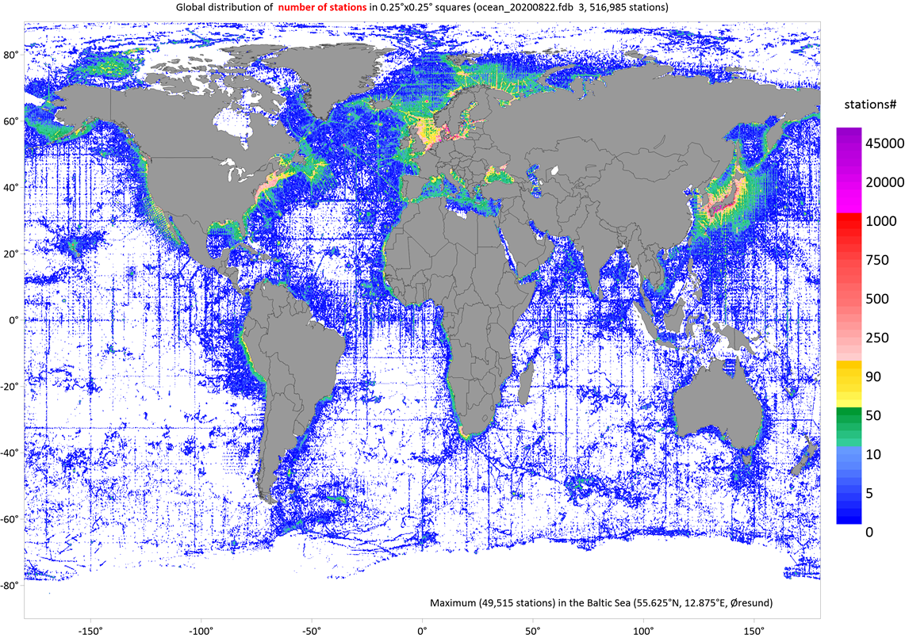

By: Alexander Korablev

Are Olsen

Steve D. Jones

Bergen

2022

Document should be cited as

Korablev A., Olsen A., Jones, S. D. Report on COMFORT dataset compilation, University of Bergen. August 2021. doi: 10.11582/2022.00039
Content

- Background
- Methods
- Data access
  - COMFORT dataset at NIRD
  - Selection and export data from the COMFORT database located in the Norwegian Research and Education Cloud (NREC)
- COMFORT database Version 2

Tables

- Data sources
- Quality control flags accepted in the database for measured values
- Relationships between metadata and data in the database / COMFORT dataset based on identification numbers (IDs)
- COMFORT_v1 versus COMFORT_v2. Comparative statistics after applying the standard deviation check

Appendices

- Variables, units, and statistics on variables
- Variables vs data sources
- Units conversion
- Quality control flags conversion
- Metadata files included into the COMFORT dataset at NIRD
- Data files included into the COMFORT dataset at NIRD

1. Background

The report describes a dataset that was compiled for the EU H2020 Project COMFORT (“Our common future ocean in the Earth system – quantifying coupled cycles of carbon, oxygen, and nutrients for determining and achieving safe operating spaces with respect to tipping points”) coordinated by the University of Bergen. COMFORT is a Research and Innovation Action project funded under the Horizon 2020 Societal Challenges programme of the European Union. The project started on September 1st 2019, has duration 48 months and consists of four core themes (CTs) and ten work packages (WPs). Overall and specific objectives can be found on the project website (https://comfort.w.uib.no/objectives/). The dataset was created under the WP1 “Ocean state under climate change” which is a part of the CT1 “Abrupt climate change, tipping elements, and tipping points”.

Collation of a new global ocean data compilation (COMFORT dataset) was specified in Task1.1 of COMFORT: “Identify tipping points and hot-spot regions and assess probability” as a global comprehensive observational dataset based on existing data such as GLODAP and new physical and biogeochemistry (BGC) observations, over the historical period, for further analysis by the consortium. Processes of interest include ocean warming, stratification, ocean acidification and deoxygenation. Tipping points and hot-spot regions are expected to be quantified using observations and modeling.

The dataset compilation workflow (briefly described in the next section) consisted of the following steps: (i) selection of original data sources, (ii) developing a relational database structure, (iii) software developing for data processing, (iv) data download and merging, (v) duplicates and quality control, (vi) data export to COMFORT dataset.

Users can access the dataset with two different approaches (NIRD and NREC), these are discussed in section 3.

2. Methods

The original data sources that were used to compile the database are listed in Table 1 along with information on the number of cruises, oceanographic stations and duplicates found. The database contains 3 707 857 stations collected at 83 568 cruises/drifting- and ice tethered profiles/aircraft missions (collectively called “cruises” in the following, for brevity)

Table 1. Data sources
 | Cruises# | Stations | duplicates | reference
GLODAP⁽¹⁾ | 840 | 59116 | 0 | https://www.nodc.noaa.gov/ocads/oceans/GLODAPv2_2019/
ITP⁽²⁾ | 107 | 102543 | 0 | https://www.whoi.edu/page.do?pid=20756
GODAR⁽³⁾ | 1815 | 125841 | 0 | https://www.nodc.noaa.gov/about/international_godar.html  https://www.nodc.noaa.gov/OC5/nordic-seas/
ARGO-BGC⁽⁴⁾ | 1236 | 186869 | 0 | http://www.argodatamgt.org/Access-to-data/Argo-DOI-Digital-Object-Identifier
WOD18⁽⁵⁾ | 79515 | 3230404 | 188597 | https://www.nodc.noaa.gov/OC5/WOD/pr_wod.html
OCADS⁽⁶⁾ | 29 | 73 | 0 | https://www.nodc.noaa.gov/ocads/
PANGAEA⁽⁷⁾ | 7 | 713 | 0 | https://www.pangaea.de/
NABOS⁽⁸⁾ | 11 | 757 | 0 | https://uaf-iarc.org/nabos-cruises/
OMG⁽⁹⁾ | 4 | 876 | 0 | https://omg.jpl.nasa.gov/portal/
NERSC⁽¹⁰⁾ | 4 | 665 | 0 | https://www.nersc.no/news/unique-oceanographic-observations-jotun-arctic-survey-east-greenland-fjord
- The Global Ocean Data Analysis Project (GLODAPv2.2019)
- Ice-Tethered Profiler
- Global Oceanographic Data Archaeology and Rescue Project
- ARGO biogeochemistry profiling floats
- World Ocean Database 2018
- Ocean Carbon Data System
- Data Publisher for Earth & Environmental Science (digital data library)
- Nansen and Amundsen Basins Observational System
- Ocean Melting Greenland
- Nansen Environmental and Remote Sensing Center

The data sources differ in number of stations, spatial / temporal coverage, vertical resolution, variables included, measurement accuracy and degree of quality control. They can be divided into groups - data from original experiments (ARGO, ITP, NABOS, OMG), data compilations (GLODAP, GODAR, WOD18), data from the project partners uploaded to various repositories (OCADS, PANGEA) and original data from project partners (NERSC). Compilations may include duplicates, so the highest priority for duplicate controls (date +/- one day, position +/- one second of latitude / longitude) was set at the original experiments. Among compilations, the lowest priority was set at WOD18 (188,567 oceanographic stations were flagged as duplicates) and the highest at GLODAP, which passed rigorous primary and secondary quality control procedures (Olsen et al., 2019, Olsen et al., 2020).

The open-source SQL relational database management system Firebird 3 (https://firebirdsql.org/) was used as a server for storing the merged oceanographic database. It runs on Microsoft Windows, Linux, macOS and Unix platforms. The OceanShell application (Korablev et al., 2014) has been considerably updated for data processing (available at https://github.com/OceanShell/OceanShell). The application uses the Firebird database server to provide fast data access. An SQLite version of the database has been created for ease of use and is the preferred method of accessing the dataset. See README.txt provided with the dataset for full details.

The database and application are based on the following basic principles, taking into account the peculiarities of hydrographic and BGC observations:

- Cruise-based organization
- Original data sources (experiments), not compilations have priority
- Original data sources have unique identification (ID) ranges in the database
- Variables are stored in their original units (if they are known)
- Units are converted ‘on the fly’
- Three quality control flags are assigned to each observation
- Each observation is associated with a type of instrument
- Flexible data selection system
- Internal (application) and external (graphic software) data visualization for quality control and analysis
- Ability to store multiple / different instruments profiles for the same oceanographic station
- Ability to assign the best profile for a variable at an oceanographic station
- Detected duplicates are not deleted in the merged database
- OceanShell contains modules for automatic data quality control
- The built-in "knowledge base" provides text information and international codes for countries, platforms, data sources, projects, institutions, principal investigators, and more
- Ability to create subsets of data and store them in a data catalogue (entry)
- Data export in several formats

These principles make it possible to develop an efficient data storage and processing system for complex BGC data. Unique identifier ranges for data sources enable them to be easily updated or replaced in the database. This is especially useful for ARGO and ITP, which are frequently updated. Keeping the original / reported units makes the uploaded data compatible with the sources, while converting units using identical formulas makes the data consistent. This is not always possible, however. Data for chemical variables in compilations like WOD and ICES are already converted to specific units.

Storing multiple profiles from different instruments (often from different sources or files) at the same station (identical ID) in a database allows profiles to be compared and their quality evaluated. All profiles belonging to one station have their own profile numbers (“prf_num”, Appendix F). Some data applications require only one profile to be processed per station. To make this possible, a special metadata field (“prf_best”, Appendix F) is reserved for identifying the one profile that is considered most appropriate for a particular task. Depending on the task, "prf_best" can be changed manually or programmatically using the appropriate algorithm.

Duplicates are stored in the database but flagged as such. These may be useful for enhancing station metadata and improving profiles composition. In the future, it will possible to create a "cleaned-up" version of the database without duplicates, redundant profiles and with a reduced vertical resolution of the profiles.

The schematic of the database design (Figure 1.1) reflects the principles and shows the relationships between metadata and data tables, as well as their content.

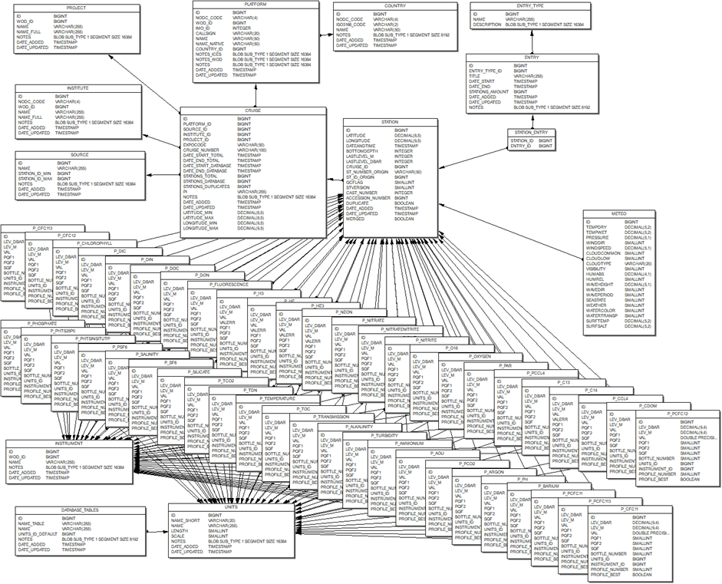

Figure 1.1. Database design

The structure of the database is designed for a three-level quality control of profiles. Each observation is accompanied by the following quality control flags:

- PQF1 – primary QC flags inherited from the original data sources
- PQF2 - primary QC flags assigned after an additional primary quality control
- SQF - QC flags set after a secondary quality control

The original system was designed to store information about inherited and assigned QC flags in the database (Table 2). It was assumed that PQF2 can be used alone (getting information from the other two QC flags) to select observations with the required quality. But in case of ITP and ARGO, the PQF2 QC flag has to be used in combination with PQF1. This is due to post-processing of ITP (raw / real time / archived) and ARGO (real time / delayed) data. ITP and ARGO profiles that did not pass delayed quality control have PQF1=0 (although observations may be good enough).

Table 2. Quality control flags accepted in the database for measured values (PQF1, PQF2)
QC flag | Meaning
-1 | duplicate value
0 | Value not checked
1 | Bad value
2 | Suspicious value
3 | Acceptable
4 | passed primary QC (set of algorithms)
5 | passed expert control (visual or other non-standard methods)
6 | passed expert control (visual or other non-standard methods)
7 | passed secondary QC (crossover, inversion analyzes) and quality confirmed (otherwise QF has to be changed to 1,2 or 4)
8 | passed secondary QC (crossover, inversion analyzes) and adjusted

The primary QC flags inherited from the data sources have been converted to the database representation according to the rules presented in Appendix D while the original quality control flags used in data sources are listed in the QC_Flags.txt file presented alongside the SQLite database.

In the current version of the database, only GLODAP data have passed the secondary quality control (Olsen et al., 2019).

The additional quality control applied to the data in this first version of the COMFORT dataset consists only of a range check. The ranges for the variables (see minimum and maximum values for observations in Appendix A) were taken from WOD18 (Appendix 11 in Garcia et al., 2018) or determined directly from data sources (mainly GLODAP and NABOS). Measurements outside ranges have been flagged with the PQF2 flag set to 1 (bad or invalid value).

The current version of the database comprises 47 data tables listed in the Appendix A. The number of hydrographic and BGC observations in the tables varies significantly with a maximum number for temperature with over 182 million observations. The default/target units of the variables (specified in 10_DATABASE_TABLES.txt) were taken from GLODAP or set to the most prevalent unit for a given variable. All reported units are also included in Appendix A along with the number of measurements in different units. The statistics for each variable (average, minimum and maximum) was computed using quality-controlled observations (PQF2>=3) and converted to default units by means of the formulas provided in Appendix C. The number of observations used for statistical calculations is indicated in the “Obs. conv” column. On a few occasions the same variables are stored in tables with different names (P_PH, P_PHTS25P0, P_PHTSINSITUTP). They came from different data sources and measurements could be made on different scales or were computed under different reference conditions for temperature and pressure. Additional work is required to merge such data. If the scale or reference conditions are known, they are indicated in the column “Var. name full” in Appendix A.

All derived variables (AOU, partial pressure of transient tracers) in the database are taken from the original data sources, mainly from GLODAP. Appendix C provides complete information on which sources the data came from and in which units.
3. Data access

The rapidly growing amount of environmental data combined with the need to adhere to the FAIR (Findability, Accessibility, Interoperability, and Reuse) principles (Wilkinson et al., 2016) are driving the development of technologies for storing and accessing data. Considering that users employ various software and require specific amounts of data or distinct variables from different locations, several alternatives for an open access to the COMFORT dataset are being offered:

- Via the National e-Infrastructure for Research Data in Norway (NIRD) where the COMFORT dataset available as relational database files and text files (https://documentation.sigma2.no/files_storage/nird.html)
- Via the Norwegian Research and Education Cloud (NREC, https://docs.nrec.no/) to download selected cruises/stations/variables directly from the COMFORT database by means of OceanShell-Export application

The NIRD solution allows to register an account at Feide OpenIdP and retrieve files using either secure shell protocol (ssh) commands or graphical interface (https://comfort.w.uib.no/guide-to-the-comfort-common-disk-space/). The OceanShell-Export is a simplified version of OceanShell software (https://github.com/OceanShell/OceanShell) designed to select and export data located in the cloud to the end user's computer. The procedures for accessing the dataset are described in the following sections.

3.1. COMFORT dataset at NIRD

This section describes the metadata and data files available from the public server at NIRD, under the doi: 10.11582/2022.00039. The original dataset was created using OceanShell backed by a Firebird database. An SQLite version of the database is provided for ease of use. This section describes the SQLite database, while the OceanShell/Firebird setup is described in Section 3.3.

Columns in the metadata and data tables are linked by unique identification numbers (IDs) depicted in Table 3. A single table can contain one or several IDs. For example, the TEMPERATURE table has three “ID” columns (Appendix F):
- column with name “ID” refer to column “ID” in the table STATION
- column with name “UNITS_ID” refer to column “ID” in the table UNITS
- column with name “INSTRUMENT_ID” refer to column “ID” in the table INSTRUMENT

Table 3. Relationships between metadata and data in the database / COMFORT dataset based on identification numbers (IDs)
# | ID name | Table | ID indicates
1 | SOURCE_ID | SOURCE | data source (name, id range etc.)
2 | CRUISE_ID | CRUISE | cruise (a subset of data associated with a specific platform and time interval)
3 | STATION_ID | STATION | oceanographic station (consists of casts (the same instr.) and profiles (different instr.))
4 | INSTRUMENT_ID | INSTRUMENT | type of instrument used for measurement
5 | PLATFORM_ID | PLATFORM | platform identification (names, codes)
6 | UNITS_ID | UNITS | unit of measurement
7 | PROJECT_ID | PROJECT | project name
8 | COUNTRY_ID | COUNTRY | country (name, code)
9 | INSTITUTE_ID | INSTITUTE | institute name
10 | DATABASE_TABLES_ID | DATABASE_TABLES | database tables (names, ID ranges)

The data tables each contain three QC flags as described in the previous section. The corresponding WOCE flags are described in Appendix D. The quality control flag schemes used in the data sources are presented in the QC_Flags.txt file.

3.2 Selection and export data from the COMFORT database located in the Norwegian Research and Education Cloud (NREC)

The OceanShell interface is experimental and unsupported.

NREC is an Infrastructure as a Service (IaaS) developed by the IT departments of the Universities of Oslo and Bergen (https://docs.nrec.no/). NREC is based on OpenStack (https://www.openstack.org/), a standard cloud computing platform that provides users with virtual servers and other resources in a private cloud. The shared (multi-user) project “COMFORT” was created on 15.01.2021 with a medium quota granted (20 instances, 40 cores, 64 GB RAM, 1.5 TB volume size). The virtual machine has an auto backup feature that creates a backup of the database twice a month. The end date of the project is 1.09.2023 which can be extended.

The ‘thick client’ approach over NREC (Fig. 3.1) is an alternative to loading data from the NIRD infrastructure. A user-friendly graphical interface is provided by the OceanShell-Export application. The COMFORT database (COMFORT_v1) and Firebird 3.0.5 server are running on a virtual machine. OceanShell-Export is available for x64 platforms such as MS Windows 10, Debian based Linux flavors, and modern MacOS versions (with some limitations).

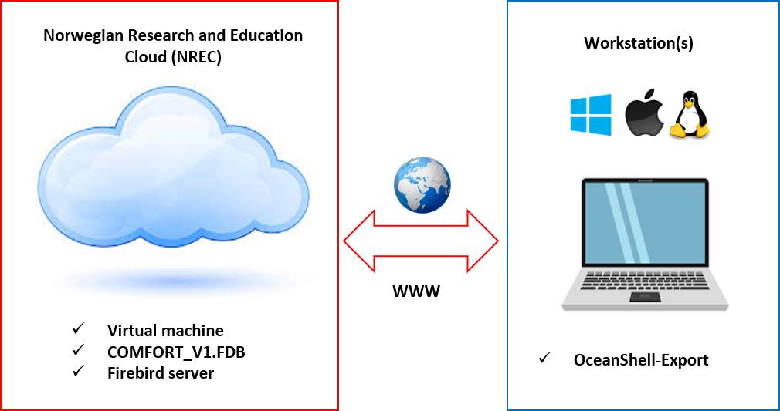

Figure 3.1 Schematic of a thick client architecture for access to the COMFORT relational database in the cloud for data selection and export.

The following steps are needed to connect to the COMFORT_v1 database:
- Download OceanShell-export binaries (https://github.com/OceanShell/OceanShell-export/releases/tag/v0.1-alpha) and unpack the archive to your workstation.
- If you are on Linux, install the following packages:
  - netcdf-dev
  - firebird-dev
- Run the binary inside of the root folder (OceanShellExport.exe for Windows, OceanShellExport for Linux and MacOS).

The main form of the OceanShell-Export application (Figure 3.2) provides a user interface for selecting data, visualizing the position of selected oceanographic stations on the globe, and exporting data in two text formats (export to netCDF is under development).

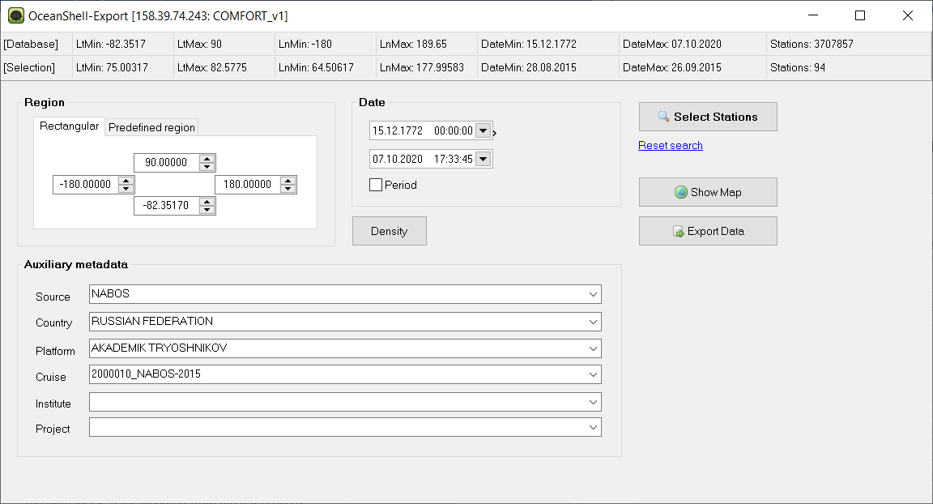

Figure 3.2 The main form of the OceanShell-Export application

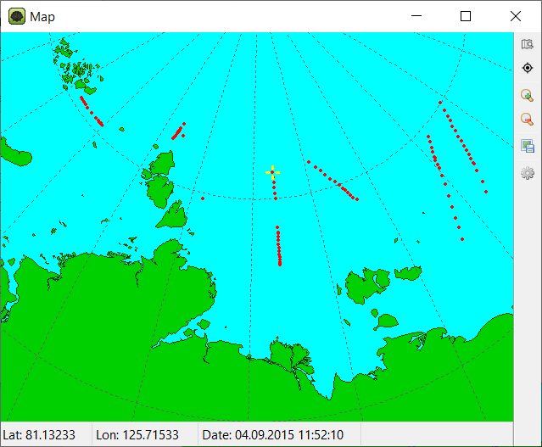
The string in the upper left corner of the form shows the application name (OceanShell-Export), the IP address of the virtual machine (158.39.74.243) and the database name (COMFORT_v1). The two information lines below provide statistics about the whole database and the selected stations. The selection tools are divided in three groups. The ‘Region’ panel allows to define latitude and longitude boundaries, while the ‘Predefined region’ tab lets users select a geographic area from a list (currently only Arctic seas). The ‘Date’ panel is intended for setting the time interval or time period (the same time interval for each year between the minimum and maximum years). The ‘Auxiliary metadata’ panel is designed for selecting oceanographic stations by the name of a data source, country, platform, institute, and project and their combinations from pop-up lists. Note that links between data and institutions / projects are not well established. The cruise list is only available if a platform is selected. The ‘Select stations’ button starts the selection process. The ‘Reset Search’ button restores the default values.

Figure 3.3 The position of the selected stations (Fig. 3.2) on the globe (left) and after zooming inn (right).

The "Show Map" button opens a map on which the selected stations are presented as points on a 3D globe (Fig. 3.3). The tools on the map toolbar located in the upper right corner of the form allow to restore the default view, center the view at the selected station, scale the map size, save the map as an image, and change map settings. A yellow cross indicates the selected station, the metadata of which are presented at the bottom of the form. The size, color of map elements, as well as the zoom step can be changed in the map settings.

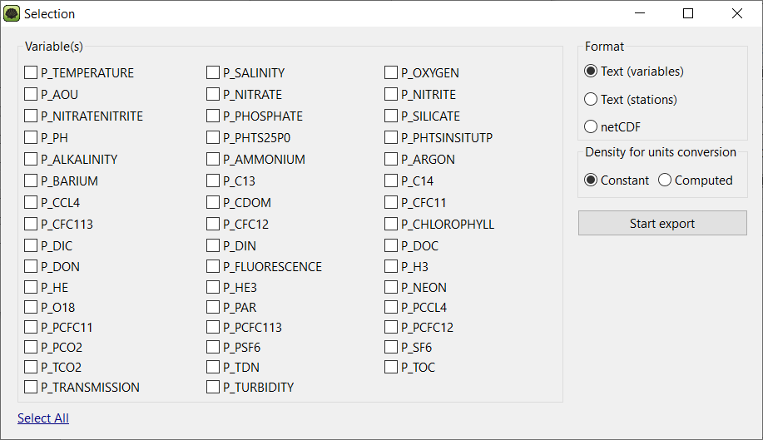

Figure 3.4 The form for variables selection and exporting.

Once selected, the data can be exported in three different formats by pressing ‘Start export’ button on the application main form. The ‘Selection’ form will appear (Fig. 3.4).

‘Text (variables)’ algorithm produces separate text files for metadata and variables linked by unique identification numbers described in Section 2. Metadata file includes 20 columns - Station_ID, Latitude, Longitude, Date_and_time, Bottom_depth, St_number_origin, St_version, Cast_number, Source_ID, Source, Cruise_ID, Cruise_number, Platform_ID, Platform, Country, PI, Institute_ID, Institute, Project_ID, Project. Variables files contain following columns - Station_ID, [dbar], [m], val, PQF1, PQF2, SQF, WOCEQF, niskin, units_id, instrument_id, prf_num, prf_best, units_def, val_conv (details in Appendix F). The format matches the contents of the variable tables in the database, with two exceptions, an extra quality control flag WOCEQF (PQF2 converted into WOCE format), and one additional column (val_conv). This val_conv column contains values converted from units of measurement to default units, if different (Appendices C and D). Unit conversion depends on the selection made in the ‘Density for units conversion’ panel. If ‘constant density’ is selected, a fixed factor of 1.025 is used to convert liters to kilograms. If ‘computed density’ is selected, the algorithms described in Appendix C are applied. Note that the second option significantly increases processing time due to additional queries to the temperature and salinity database tables between the client and server and time required for density calculation. Upon completion, several files will be saved in a user-defined folder, including metadata.txt. For testing purposes, the export time is shown under the ‘Start Export’ button during the data processing.

In the ‘Text (stations)’ format, metadata and selected variables are combined. The output does not contain QC flags because only values with PQF2> 2 are included (Table 2, Appendix D). The algorithm combines profiles from different database tables according to the type of instrument, the number of the profile that belongs to the instrument, and the depth of measurement. If no match is found, the variable is written as a single profile belonging to the station. When the selected stations are ready, the user will be prompted to select the folder in which the data on the workstation will be stored. The ‘data.txt’ file will be created in the selected folder. At the beginning of the file, brief information is provided about types of instruments, abbreviations, and default value. Station data consist of metadata and profiles. A fixed number of lines reserved for metadata with an explanation at the first station, followed by the profile data.

For example (extraction from different profiles at the station):
2000519 (station_id)
2000010 (cruise_id)
10 (source_id)
NABOS (source_name)
21688 (platform_id)
AKADEMIK TRYOSHNIKOV (platform_name)
NABOS-2015 (cruise_number)
IGOR POLYAKOV (PI)
82.16267 (latitude deg.)
94.8155 (longitude deg.)
28.08.2015 9:30:34 (station date and time)
-9999 (bottom depth)
AT001 (st_number_origin)
0 (station version)
1 (cast number)
3 (number of variables at station)
4552 (number of records at station)
[dbar] [m] inst prfn P_TEMPERATURE(°C) P_SALINITY(1) P_OXYGEN(μmol·kg-1)
4.0 4.0 4 1 -1.578 32.147 363.366
5.0 4.9 4 1 -1.576 32.147 363.216
6.0 5.9 4 1 -1.576 32.147 362.999
7.0 6.9 4 1 -1.576 32.147 362.800
8.0 7.9 4 1 -1.575 32.150 362.778
9.0 8.9 4 1 -1.575 32.152 363.419
10.0 9.9 4 1 -1.575 32.152 363.913
11.0 10.9 4 1 -1.575 32.152 364.781
12.0 11.9 4 1 -1.569 32.160 365.456
13.0 12.9 4 1 -1.567 32.162 365.782
14.0 13.9 4 1 -1.565 32.167 365.540
15.0 14.8 4 1 -1.545 32.250 365.902
2256.0 2220.0 4 2 -0.748 34.926 285.051
2257.0 2221.0 4 2 -0.748 34.926 285.097
2258.0 2222.0 4 2 -0.748 34.926 284.992
2259.0 2223.0 4 2 -0.748 34.926 284.817
2260.0 2224.0 4 2 -0.748 34.926 284.858
2261.0 2224.9 4 2 -0.748 34.926 284.904
2262.0 2225.9 4 2 -0.748 34.926 284.998
2263.0 2226.9 4 2 -0.747 34.926 285.112
2.9 2.9 7 1 -1.524 32.139 -9999.000
3.0 2.9 7 1 -1.510 32.106 -9999.000
3.0 2.9 7 1 -1.538 32.128 -9999.000
10.4 10.3 7 1 -1.550 32.453 387.706
20.4 20.2 7 1 -1.566 33.899 -9999.000
20.8 20.6 7 1 -1.562 33.908 -9999.000
29.3 29.0 7 1 -1.732 34.289 -9999.000
41.0 40.5 7 1 -1.669 34.444 329.002

Unique identifiers can be used to associate data with other formats (at NIRD) with complete metadata and profiles. The number of variables and records given at station simplifies data processing. Variables are converted to default units, if necessary, according to the equations listed in Appendix C. It should be emphasized that the thick client data access approach is designed to export a small amount of data.. Exporting stations with high-resolution CTD profiles requires much more resources than sparse bottle samples. Another costly procedure is unit conversion using the computed density (requires multiple queries to the database for every measurement).

Unit conversion formulas are used for ‘on-the-fly’ calculations in the OceanShell application and during data export from the database. Liters to kilograms were converted using either a fixed factor of 1.025 (on-the-fly) or computed density (export) while conversion from grams to moles depends on the molar mass (weight) of a substance (https://ocean.ices.dk/tools/unitconversion.aspx). To make the converted values consistent with already converted data from GLODAP and WOD, molar mass of nitrogen (N) was used to convert nitrate, nitrite, nitrate + nitrite, molar mass of phosphorus (P) to convert phosphate, molar mass of silicon (Si) to convert silicate. Molar masses and conversion factors are included in Appendix C. The converted values are for reference and users can use their own formulas for conversion.

5. COMFORT database version 2

The COMFORT_v2 database contains the same data as COMFORT_v1, except that an additional quality control check has been applied. The database file (COMFORT_v2.fbk as an archived backup) available in /tos-project2/NS2980K/COMFORT_shared/WP1/COMFORT dataset/databases folder at NIRD. All measurements included in the database were checked for deviation from the mean profile calculated in 4ºx4º geographic squares to identify outliers and set quality control flags (Figure 5.1).
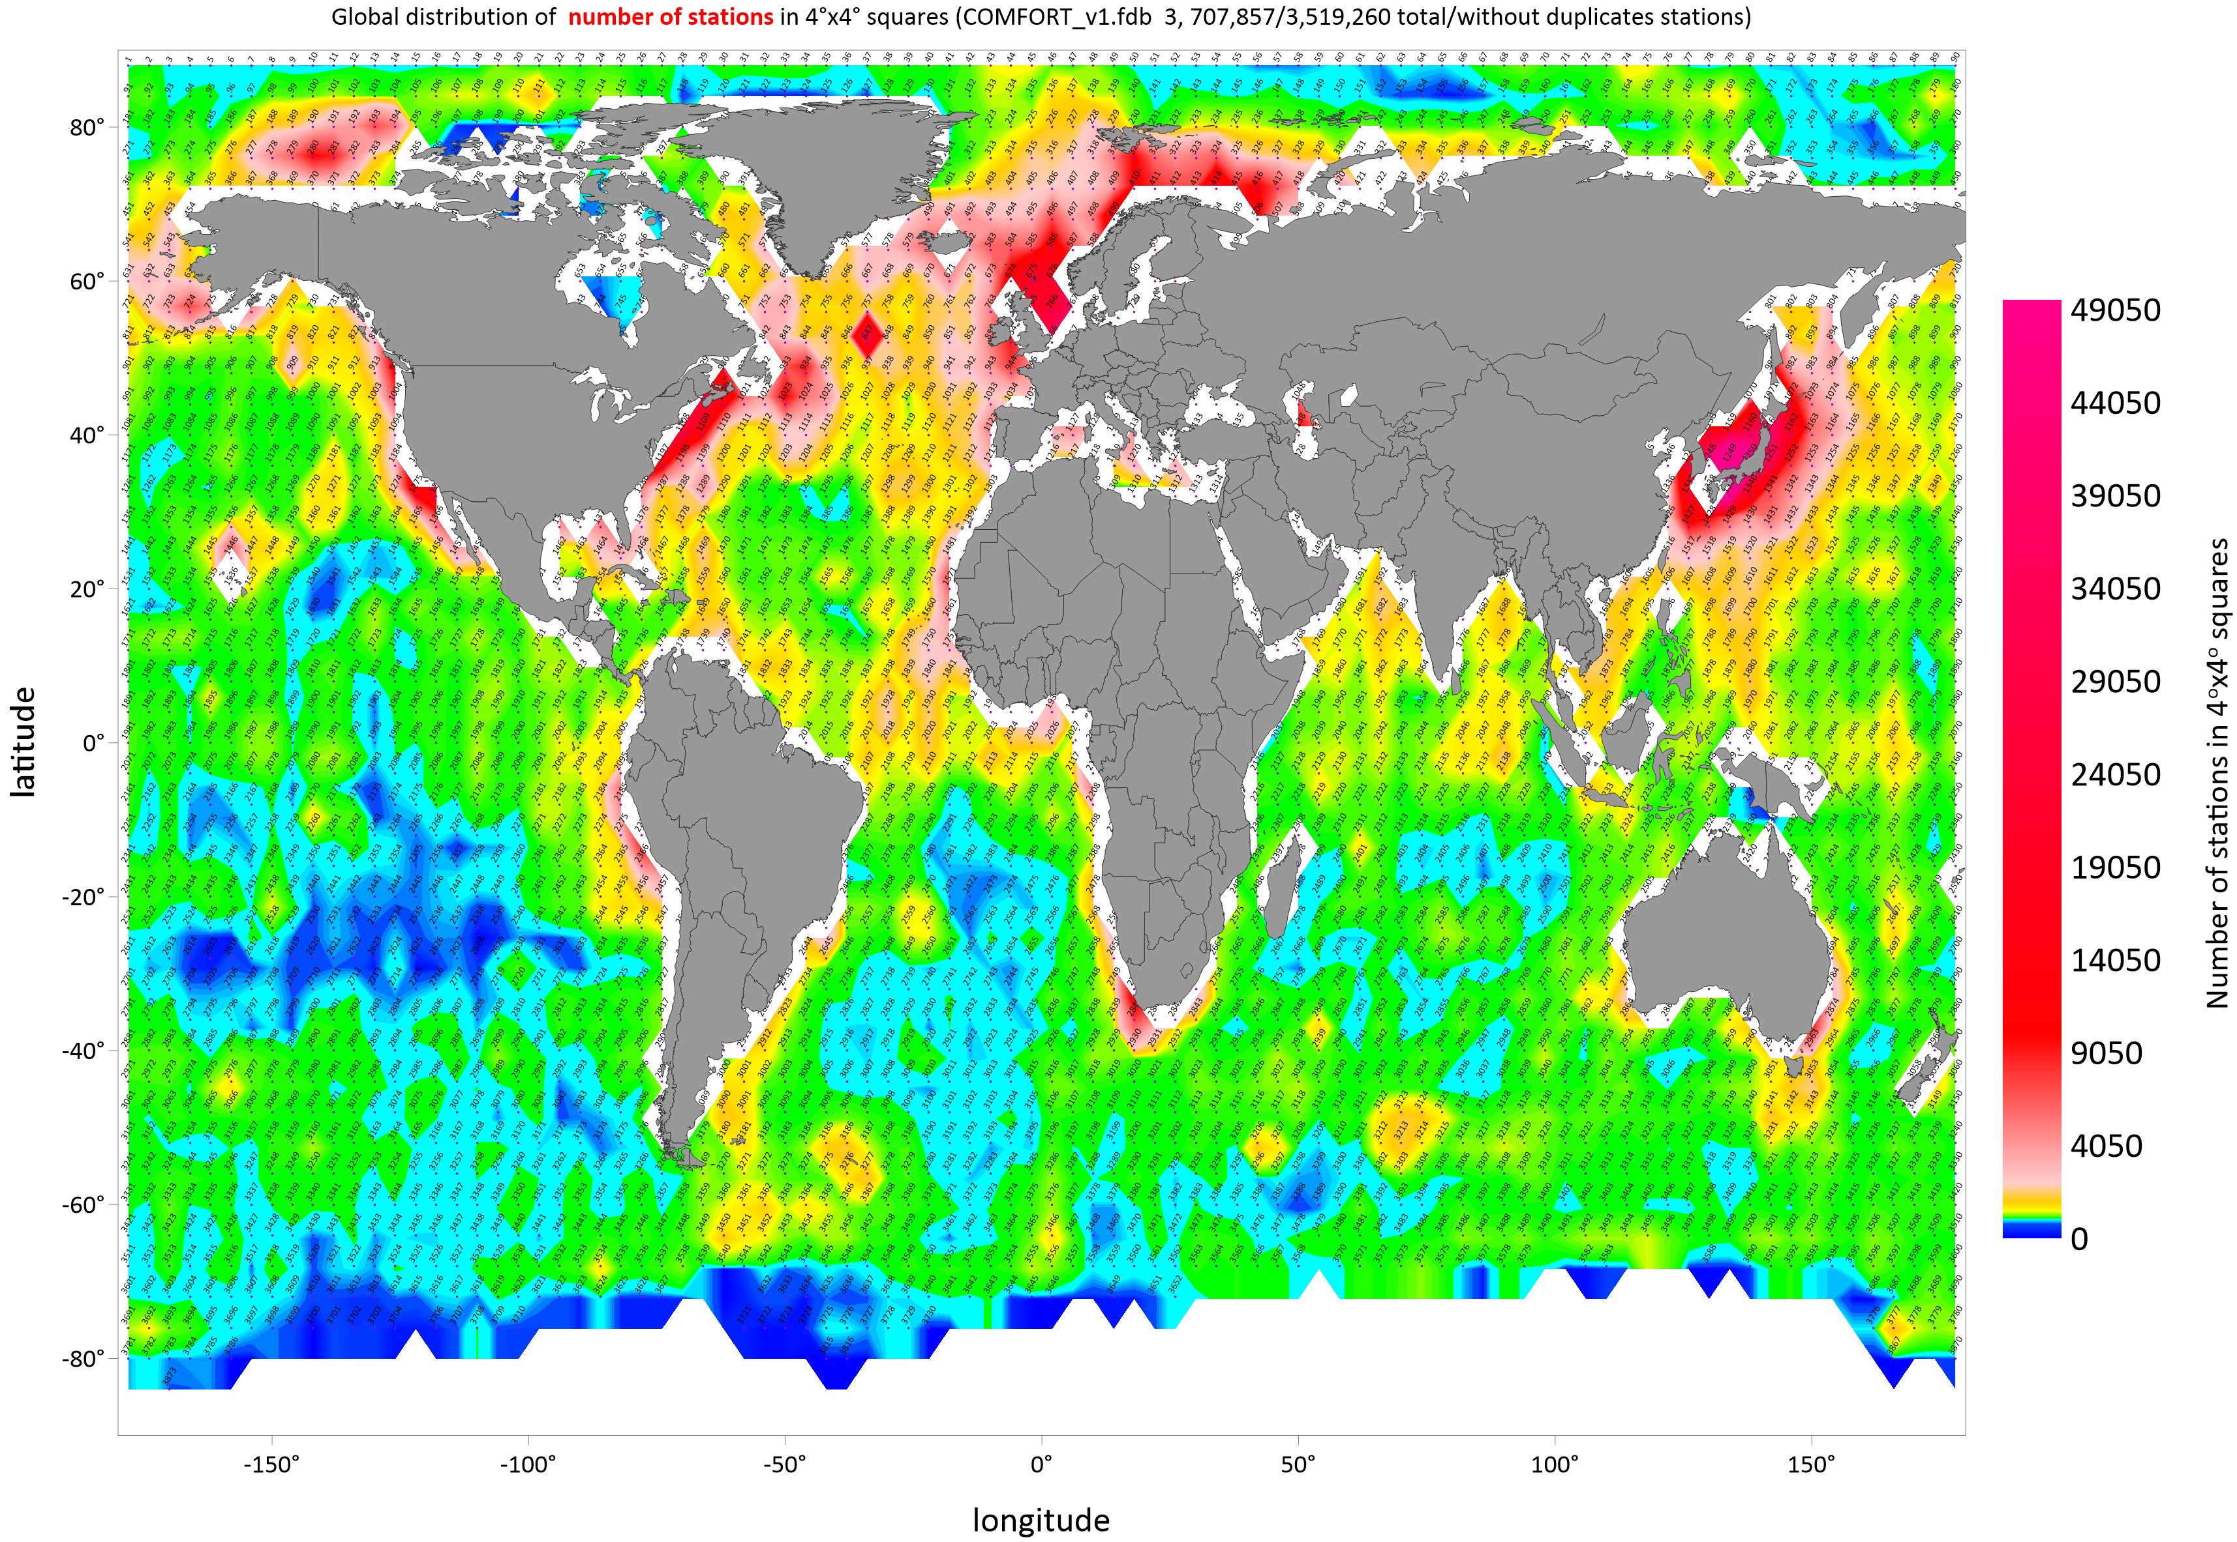
Figure 5.1 Global distribution of the number of oceanographic stations (color fill) in 4ºx4º squares in the COMFORT_v1, COMFORT_v2 databases. The tilted numbers indicate the sequential numbers of the squares.

To calculate the standard deviations, the water column was divided into the same depth layers (44 layers of variable thickness) as in Shahzadi et al., 2019 (their table 3). After experimenting with the effect of the standard deviation factor (sd) on the number of outliers, a depth-dependent scheme was chosen with the following conditions:
- +/- 5 sd in 0 – 50 m layer
- +/- 4 sd in 50 – 500 m layer
- +/- 3 sd deeper than 500 m
- minimum 10 samples in a layer if the measurement depth is less than 2000 m
- minimum 5 samples in a layer if the measurement depth is greater than 2000 m

The algorithm detects outliers, as shown in Figure 5.2, where dissolved oxygen is taken as an example. For observations marked with red squares, PQF2 was set to 2 (suspicious value).

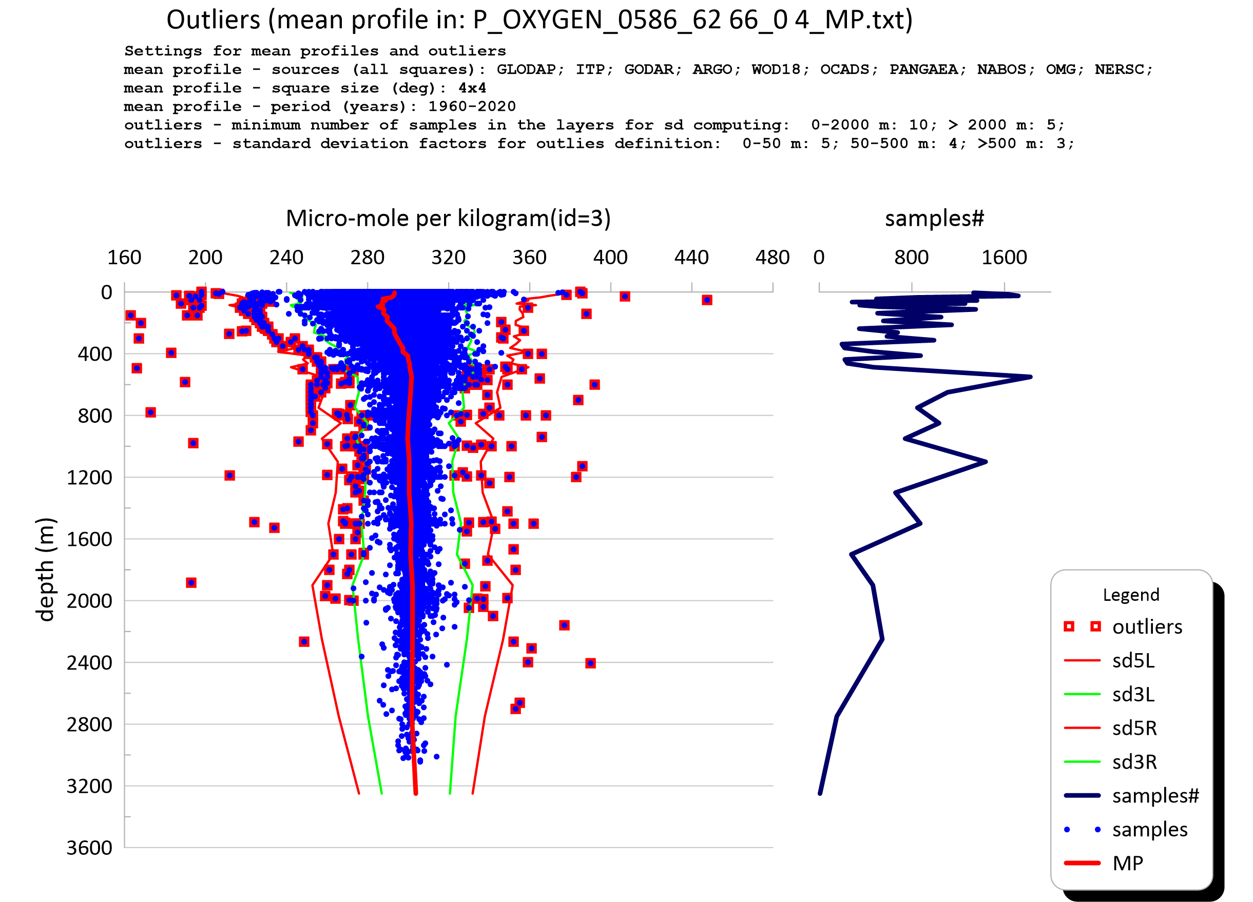

Figure 5.2 An example of outliers’ detection in square 586 (62º-66º north, 0º-4º east).

Obviously, the algorithm works well only if there are enough observations in layers to calculate a reliable mean profile. It also depends on what the purpose of the study is. If extreme values are the main goal, it is better to use the original values. On the contrary, if the subject of research is the mean state, the algorithm can be applied several times. Table 4 shows that many variables remained unchanged after the algorithm was applied. The total number of newly flagged observations for individual variables in COMFORT_v2 does not exceed 1% relative to the COMFORT_v1 database / dataset.

In addition, the program module which implements the outliers check also generates files that can be used to visualize problematic stations and set the flags manually (file by file). The external program Goldensoftware-"Grapher" creates the graphs shown in Figure 5.2 in automatic mode for visual control. For example, plots for dissolved oxygen are available at NIRD in /tos-project2/NS2980K/COMFORT_shared/WP1/COMFORT dataset/version_02/outliers/Oxygen folder.

Table 4. COMFORT_v1 versus COMFORT_v2. Comparative statistics after applying the standard deviation check

Variable | #⁽¹⁾ | Id⁽²⁾ | default unit | COMFORT_v1 |  |  |  | COMFORT_v2 |  |  |  | v1-v2(⁴⁾ | %⁽⁵⁾
 |  |  |  | obs.#⁽³⁾ | avg | min | max | obs.#⁽³⁾ | avg | min | max
ALKALINITY | 2 | 3 | μmol·kg-1 | 737269 | 2174.42 | 0 | 3238.049 | 733941 | 2174.044 | 0 | 3238.049 | 3328 | 0.45
AMMONIUM | 2 | 14 | μg·kg-1 | 2437 | 0.534 | 0 | 22.081 | 2437 | 0.534 | 0 | 22.081 | 0
AOU | 1 | 3 | μmol·kg-1 | 988170 | 102.16 | -345.32 | 327.13 | 988157 | 102.162 | -345.32 | 327.13 | 13 | 0.00
ARGON | 1 | 12 | nmol·kg-1 | 2077 | 14.942 | 9.46 | 17.85 | 2077 | 14.942 | 9.46 | 17.85 | 0
BARIUM | 2 | 3 | μmol·kg-1 | 1342 | 0.185 | 0.001 | 0.387 | 1342 | 0.185 | 0.001 | 0.387 | 0
C13 | 1 | 11 | ‰ | 39183 | 0.555 | -27 | 3.1 | 39183 | 0.555 | -27 | 3.1 | 0
C14 | 1 | 11 | ‰ | 40857 | -87.157 | -268.1 | 478 | 40857 | -87.157 | -268.1 | 478 | 0
CCL4 | 1 | 13 | pmol·kg-1 | 43112 | 2.695 | -0.243 | 17.327 | 43112 | 2.695 | -0.243 | 17.327 | 0
CDOM | 1 | 24 | ppb | 1834416 | 3.303 | 0 | 106 | 1834404 | 3.303 | 0 | 106 | 12 | 0.00
CFC11 | 1 | 13 | pmol·kg-1 | 383452 | 1.513 | -0.137 | 9.98 | 383429 | 1.513 | -0.137 | 9.98 | 23 | 0.01
CFC113 | 1 | 13 | pmol·kg-1 | 117871 | 0.124 | -0.156 | 2.7 | 117829 | 0.124 | -0.156 | 2.7 | 42 | 0.04
CFC12 | 1 | 13 | pmol·kg-1 | 390170 | 0.805 | -0.07 | 8.85 | 390122 | 0.805 | -0.07 | 8.85 | 48 | 0.01
CHLOROPHYLL | 2 | 14 | μg·kg-1 | 2067649 | 0.831 | -0.088 | 48.78 | 2062543 | 0.804 | -0.088 | 48.78 | 5106 | 0.25
DIC | 2 | 3 | μmol·kg-1 | 389784 | 2185.866 | 0 | 2651.22 | 389739 | 2185.876 | 0 | 2651.22 | 45 | 0.01
DIN | 2 | 14 | μg·kg-1 | 2473 | 7.466 | 0.031 | 34.713 | 2473 | 7.466 | 0.031 | 34.713 | 0
DOC | 1 | 15 | μmol·l-1 | 53506 | 48.144 | 23.148 | 423.03 | 53506 | 48.144 | 23.148 | 423.03 | 0
DON | 1 | 15 | μmol·l-1 | 1672 | 19.275 | 1.08 | 605.57 | 1672 | 19.275 | 1.08 | 605.57 | 0
FLUORESCENCE | 2 | 9 | μg·m-3 | 254899 | 5.187 | -0.086 | 347.127 | 254899 | 5.187 | -0.086 | 347.127 | 0
H3 | 1 | 8 | TU | 31869 | 1.297 | -0.18 | 258 | 31869 | 1.297 | -0.18 | 258 | 0
HE | 1 | 12 | nmol·kg-1 | 39810 | 1.833 | -1.92 | 32 | 39810 | 1.833 | -1.92 | 32 | 0
HE3 | 1 | 10 | % | 43238 | 7.107 | -15.400 | 50.7 | 43238 | 7.107 | -15.4 | 50.7 | 0
NEON | 1 | 12 | nmol·kg-1 | 25945 | 7.632 | 0 | 23.5 | 25945 | 7.632 | 0 | 23.5 | 0
NITRATE | 4 | 3 | μmol·kg-1 | 3499833 | 13.8 | -0.9 | 488 | 3482619 | 13.746 | -0.9 | 488 | 17214 | 0.49
NITRATENITRITE | 2 | 3 | μmol·kg-1 | 2037 | 5.557 | 0.001 | 17.53 | 2036 | 5.553 | 0.001 | 17.53 | 1 | 0.05
NITRITE | 4 | 3 | μmol·kg-1 | 772196 | 0.041 | -0.195 | 11.59 | 771208 | 0.041 | -0.195 | 11.59 | 988 | 0.13
O18 | 1 | 11 | ‰ | 14890 | -1.026 | -26.09 | 12.456 | 14888 | -1.025 | -20.2 | 12.456 | 2 | 0.01
OXYGEN | 3 | 3 | μmol·kg-1 | 45293723 | 230.476 | 0.000 | 523 | 45215725 | 230.549 | 0 | 523 | 77998 | 0.17
PAR | 2 | 23 | µmol m-2 s-1 | 943513 | 3.481 | -24.3 | 40.5 | 943513 | 3.481 | -24.3 | 40.5 | 0
PCCL4 | 1 | 18 | ppt | 40382 | 128.32 | -10.101 | 691.42 | 40382 | 128.32 | -10.101 | 691.42 | 0
PCFC11 | 1 | 18 | ppt | 347202 | 94.293 | -4.865 | 462.1 | 347201 | 94.294 | -4.865 | 462.1 | 1 | 0.00
PCFC113 | 1 | 18 | ppt | 108942 | 19.81 | -21.128 | 273.05 | 108936 | 19.811 | -21.128 | 273.05 | 6 | 0.01
PCFC12 | 1 | 18 | ppt | 351788 | 196.002 | -10.754 | 1601.405 | 351788 | 196.002 | -10.754 | 1601.405 | 0
PCO2 | 1 | 6 | μatm | 36654 | 734.147 | 92.954 | 2617.9 | 36654 | 734.147 | 92.954 | 2617.9 | 0
PH | 1 | 2 | 1 | 2351861 | 8.07 | 6.3 | 9.2 | 2346375 | 8.071 | 6.3 | 9.2 | 5486 | 0.23
PHOSPHATE | 4 | 3 | μmol·kg-1 | 5466251 | 1.1 | -0.214 | 56.1 | 5434215 | 1.093 | -0.214 | 27.1 | 32036 | 0.59
PHTS25P0 | 1 | 2 | 1 | 234580 | 7.705 | 7.074 | 8.364 | 234578 | 7.705 | 7.074 | 8.364 | 2 | 0.00
PHTSINSITUTP | 1 | 2 | 1 | 210971 | 7.904 | 7.383 | 8.497 | 210971 | 7.904 | 7.383 | 8.497 | 0
PSF6 | 1 | 18 | ppt | 73737 | 2.734 | -0.233 | 22.449 | 73734 | 2.734 | -0.233 | 22.449 | 3 | 0.00
SALINITY | 1 | 2 | 1 | 134101246 | 34.016 | 0 | 40 | 133873666 | 34.017 | 0 | 40 | 227580 | 0.17
SF6 | 1 | 19 | fmol·kg-1 | 74703 | 0.792 | -0.09 | 6.55 | 74700 | 0.792 | -0.09 | 6.55 | 3 | 0.00
SILICATE | 4 | 3 | μmol·kg-1 | 4268034 | 29.5 | -2.02 | 336.95 | 4242073 | 29.273 | -2.02 | 285.85 | 25961 | 0.61
TCO2 | 1 | 3 | μmol·kg-1 | 423059 | 2185.426 | 141.7 | 2651.2 | 423059 | 2185.426 | 141.7 | 2651.2 | 0
TDN | 1 | 15 | μmol·l-1 | 29772 | 25.361 | 1.290 | 52.8 | 29772 | 25.361 | 1.29 | 52.8 | 0
TEMPERATURE | 1 | 1 | °C | 140093976 | 5.55 | -3 | 35.4 | 139949515 | 5.548 | -3 | 35.4 | 144461 | 0.1
TOC | 1 | 15 | μmol·l-1 | 3084 | 61.706 | 28 | 505.95 | 3084 | 61.706 | 28 | 505.95 | 0
TRANSMISSION | 1 | 10 | % | 464551 | 95.404 | 40.85 | 100.325 | 464551 | 95.404 | 40.85 | 100.325 | 0
TURBIDITY | 2 | 22 | (m-1 sr-1)10^4 | 23459 | 0.67 | 0.055 | 15.213 | 23459 | 0.67 | 0.055 | 15.213 | 0
- Number of different units in the database table
- ID of the default unit (06_UNITS.txt)
- Number of observations with PQF2>2 and PQF1≠0 (ITP and AGRO)
- Difference in number of observations between COMFORT version 1 and 2, where PQF2>2 and PQF1≠0 (ITP and AGRO)
- The same - percentage

REFERENCES

Citations to cruises used under PANGAEA source name are listed in the appendix D.

Argo User’s manual, September 2017, http://dx.doi.org/10.13155/29825

Garcia, H. E., T. P. Boyer, R. A. Locarnini, O. K. Baranova, M. M. Zweng (2018). World Ocean Database 2018: User’s Manual (prerelease). A.V. Mishonov, Technical Ed., NOAA, Silver Spring, MD (Available at https://www.NCEI.noaa.gov/OC5/WOD/pr_wod.html).

Korablev, A., A. Smirnov, and O. K. Baranova, 2014. Climatological Atlas of the Nordic Seas and Northern North Atlantic. D. Seidov, A. R. Parsons, Eds., NOAA Atlas NESDIS 77, 122 pp., dataset doi: 10.7289/V54B2Z78.

Olsen, A., Lange, N., Key, R. M., Tanhua, T., Álvarez, M., Becker, S., Bittig, H. C., Carter, B. R., Cotrim da Cunha, L., Feely, R. A., van Heuven, S., Hoppema, M., Ishii, M., Jeansson, E., Jones, S. D., Jutterström, S., Karlsen, M. K., Kozyr, A., Lauvset, S. K., Lo Monaco, C., Murata, A., Pérez, F. F., Pfeil, B., Schirnick, C., Steinfeldt, R., Suzuki, T., Telszewski, M., Tilbrook, B., Velo, A., and Wanninkhof, R.: GLODAPv2.2019 – an update of GLODAPv2, Earth Syst. Sci. Data, 11, 1437–1461, https://doi.org/10.5194/essd-11-1437-2019, 2019.

Olsen, A., Lange, N., Key, R. M., Tanhua, T., Bittig, H. C., Kozyr, A., Àlvarez, M., Azetsu-Scott, K., Becker, S., Brown, P. J., Carter, B. R., Cotrim da Cunha, L., Feely, R. A., van Heuven, S., Hoppema, M., Ishii, M., Jeansson, E., Jutterström, S., Landa, C. S., Lauvset, S. K., Michaelis, P., Murata, A., Pérez, F. F., Pfeil, B., Schirnick, C., Steinfeldt, R., Suzuki, T., Tilbrook, B., Velo, A., Wanninkhof, R., and Woosley, R. J.: GLODAPv2.2020 – the second update of GLODAPv2, Earth Syst. Sci. Data Discuss. [preprint], https://doi.org/10.5194/essd-2020-165, in review, 2020.

Shahzadi, K., N.Pinardi, V.Lyubartsev, M.Zavatarelli and S. Simoncelli, 2019. Global
Ocean Temperature and Salinity climatology from the World Ocean Data profiles,
Version 1

Wilkinson, M. D. et al. The FAIR Guiding Principles for scientific data management and stewardship. Sci. Data 3:160018 doi: 10.1038/sdata.2016.18 (2016).

ACKNOWLEDGEMENTS

“This project has received funding from the European Union’s Horizon 2020 research and innovation programme under grant agreement No 820989 (project COMFORT, Our common future ocean in the Earth system – quantifying coupled cycles of carbon, oxygen, and nutrients for determining and achieving safe operating spaces with respect to tipping points). The work reflects only the author’s/authors’ view; the European Commission and their executive agency are not responsible for any use that may be made of the information the work contains.”

The Ice-Tethered Profiler data were collected and made available by the Ice-Tethered Profiler Program (Toole et al., 2011; Krishfield et al., 2008) based at the Woods Hole Oceanographic Institution (https://www.whoi.edu/itp).

ARGO data were collected and made freely available by the International Argo Program and the national programs that contribute to it. (http://www.argo.ucsd.edu, http://argo.jcommops.org). The Argo Program is part of the Global Ocean Observing System.

APPENDIX A: Variables, units, and statistics on variables

ID | Var. name  short | Var. name  full | Obs.  total #⁽¹⁾ | Def. unit⁽²⁾ |  | Other units |  |  | Statistics⁽⁴⁾
 |  |  |  | ID | name | ID | name | # | Obs. Conv.⁽³⁾ | average | Min | max
1 | TEMPERATURE | Sea water temperature | 182164050 | 1 | (°C) |  |  |  | 179920381 | 6.24 | -3 | 35.4
2 | SALINITY | Sea water salinity | 175645335 | 2 | Psu |  |  |  | 173714014 | 34.202 | 0 | 40
3 | OXYGEN | Dissolved Oxygen | 67085418 | 3 | μmol/kg | 10  21 | %  ml/l | 66233485  243  851690 | 65768168 | 192.22 | 0 | 523
4 | AOU | Apparent oxygen utilization | 988170 | 3 | μmol/kg |  |  |  | 988170 | 102.16 | -345.32 | 327.13
5 | NITRATE | Nitrate | 4442685 | 3 | μmol/kg | 4  14  26 | μg/l  μg/kg  μg·at/kg | 4384469  56324  1302  590 | 3499833 | 13.8 | -0.9 | 488
6 | NITRITE | Nitrite | 772398 | 3 | μmol/kg | 4  14  26 | μg/l  μg/kg  μg·at/kg | 685121  85376  1302  599 | 772196 | 0.041 | -0.195 | 11.590
7 | SILICATE | Silicate | 5245829 | 3 | μmol/kg | 4  14  26 | μg/l  μg/kg  μg·at/kg | 5105943  137981  1302  603 | 4268034 | 29.5 | -2.02 | 336.95
8 | PHOSPHATE | Phosphate | 6470997 | 3 | μmol/kg | 4  14  26 | μg/l  μg/kg  μg·at/kg | 6280350  188795  1302  550 | 5466251 | 1.1 | -0.214 | 56.1
9 | TCO2 | Dissolved inorganic carbon (20ºC, 0 dbar) | 423059 | 3 | μmol/kg |  |  |  | 423059 | 2185.42 | 141.7 | 2651.2
10 | ALKALINITY | Alkalinity | 1148686 | 3 | μmol/kg | 5 | meq/l | 372552  776134 | 737269 | 2174.42 | 0 | 3238.049
11 | PHTS25P0 | pH on total scale (25ºC, 0 dbar) | 234580 | 2 |  |  |  |  | 234580 | 7.705 | 7.074 | 8.364
12 | PHTSINSITUTP | pH on total scale (in situ temperature and pressure) | 210971 | 2 |  |  |  |  | 210971 | 7.904 | 7.383 | 8.497
13 | CFC11 | Halogenated transient tracer CFC11 | 717504 | 13 | pmol/kg |  |  |  | 383452 | 1.513 | -0.137 | 9.98
14 | PCFC11 | Halogenated transient tracer CFC11 (partial pressure) | 347202 | 18 | ppt |  |  |  | 347202 | 94.293 | -4.865 | 462.1
15 | CFC12 | Halogenated transient tracer CFC12 | 722344 | 13 | pmol/kg |  |  |  | 390170 | 0.805 | -0.07 | 8.85
16 | PCFC12 | Halogenated transient tracer CFC12 (partial pressure) | 351788 | 18 | ppt |  |  |  | 351788 | 196.002 | -10.754 | 1601.405
17 | CFC113 | Halogenated transient tracer CFC113 | 246882 | 13 | pmol/kg |  |  |  | 117871 | 0.124 | -0.156 | 2.7
18 | PCFC113 | Halogenated transient tracer CFC113 (partial pressure) | 108942 | 18 | ppt |  |  |  | 108942 | 19.81 | -21.128 | 273.05
19 | CCL4 | Carbone tetrachloride CCL4 | 43112 | 13 | pmol/kg |  |  |  | 43112 | 2.695 | -0.243 | 17.327
20 | PCCL4 | Carbone tetrachloride CCL4 (partial pressure) | 40382 | 18 | ppt |  |  |  | 40382 | 128.32 | -10.101 | 691.42
21 | SF6 | Sulfur hexafluoride | 74703 | 19 | fmol/kg |  |  |  | 74703 | 0.792 | -0.09 | 6.55
22 | PSF6 | Sulfur hexafluoride (partial pressure) | 73737 | 18 | ppt |  |  |  | 73737 | 2.734 | -0.233 | 22.449
23 | C13 | Stable isotope carbon 13 | 70222 | 11 | ‰ |  |  |  | 39183 | 0.555 | -27 | 3.1
24 | C14 | Radioisotope carbon 14, counting error | 73974 | 11 | ‰ |  |  |  | 40857 | -87.157 | -268.1 | 478
25 | H3 | Radioisotope hydrogen 3 (tritium) | 60255 | 8 | TU |  |  |  | 31869 | 1.297 | -0.18 | 258
26 | HE3 | Radioisotope helium 3, counting error | 76921 | 10 | % |  |  |  | 43238 | 7.107 | 15.4 | 50.7
27 | HE | Helium, counting error | 79711 | 12 | nmol/kg |  |  |  | 39810 | 1.833 | -1.92 | 32
28 | NEON | Neon, counting error | 52530 | 12 | nmol/kg |  |  |  | 25945 | 7.632 | 0 | 23.5
29 | O18 | Stable isotop of oxygen 18 | 25821 | 11 | ‰ |  |  |  | 14890 | -1.026 | -26.09 | 12.456
30 | TOC | Total organic carbon | 3084 | 15 | μmol/l |  |  |  | 3084 | 61.706 | 40.85 | 100.325
31 | DOC | Dissolved organic carbon | 53506 | 15 | μmol/l |  |  |  | 53506 | 48.144 | 23.148 | 423.03
32 | DON | Dissolved organic nitrogen | 1672 | 15 | μmol/l |  |  |  | 1672 | 19.275 | 1.08 | 605.57
33 | TDN | Total dissolved nitrogen | 29772 | 15 | μmol/l |  |  |  | 29772 | 25.361 | 1.29 | 52.8
35 | CDOM | Colored dissolved organic matter | 2198560 | 24 | ppb |  |  |  | 2198546 | 3.209 | 0 | 106
36 | PAR | Photosynthetic active radiation | 1304967 | 23 | µmol m-2 s-1 | 21 | ml/l | 1276758  28209 | 943513 | 3.481 | -24.3 | 40.5
37 | TURBIDITY | Ocean turbidity | 499019 | 22 | (m-1 sr-1)10^4 | 25 | NTU | 387598  111421 | 23459 | 0.67 | 0.055 | 15.213
38 | NITRATENITRITE | Combined nitrate and nitrite | 2162 | 3 | μmol/kg | 4 | μg/l | 866  1296 | 2037 | 5.557 | 0.001 | 17.53
39 | BARIUM | Barium | 1342 | 3 | μmol/kg | 7  14 | mmol/l  μg/kg | 644  698 | 1342 | 0.185 | 0.001 | 0.387
41 | CHLOROPHYLL | Chlorophyll | 2668366 | 14 | μg/kg | 4 | μg/l | 42861  2625505 | 2431779 | 0.718 | -0.088 | 48.78
42 | DIN | Dissolved inorganic nitrogen | 2598 | 14 | μg/kg | 4 | μg/l | 1302  1296 | 2473 | 7.466 | 0.031 | 34.713
43 | DIC | Dissolved inorganic carbon | 393661 | 3 | μmol/kg | 7 | mmol/l | 485  393176 | 389784 | 2185.866 | 0 | 2651.22
44 | FLUORESCENCE | Fluorescence | 281588 | 9 | μg /m³ | 22 | (m⁻¹ sr⁻¹)10⁴ | 254911  26677 | 254899 | 5.187 | -0.086 | 347.127
45 | TRANSMISSION | Transmission | 529433 | 10 | % |  |  |  | 464551 | 95.404 | 40.85 | 100.325
46 | ARGON | Argon | 2077 | 12 | nmol/kg |  |  |  | 2077 | 14.942 | 9.46 | 17.85
47 | AMMONIUM | Ammonium | 2598 | 14 | μg/kg | 4 | μg/l | 1302  1296 | 2437 | 0.534 | 0 | 22.081
48 | PCO2 | Total inorganic carbon (partial pressure) | 37055 | 6 | μatm |  |  |  | 36654 | 734.147 | 92.954 | 2617.9
49 | PH | PH | 2715066 | 2 |  |  |  |  | 2351861 | 8.070 | 6.3 | 9.2
- Total number of observations in the database table
- Default unit of measure to which other units are converted
- Number of observations used to compute statistics in the default unit (duplicates and poor-quality observations (PQF2>2, PQF1≠0) are excluded)
- Statistics have been calculated using a fixed factor of 1.025 to convert liters to kilograms

APPENDIX B: Variables vs data sources

ID | Variable name  short | Variable name  full | Obs.  total #⁽¹⁾ | Data sources (number of obs., units ID composition)
1 | TEMPERATURE | Sea water temperature | 182164050 | GLODAP(samples:1611628, units:1;), ITP(samples:42669668, units:1;), GODAR(samples:1036425, units:1;), ARGO(samples:101485632, units:1;), WOD18(samples:27956143, units:1;), OCADS(samples:894, units:1;), PANGAEA(samples:1700664, units:1;), NABOS(samples:1024993, units:1;), OMG(samples:4469210, units:1;), NERSC(samples:208793, units:1;)
2 | SALINITY | Sea water salinity | 175645335 | GLODAP(samples:1590461, units:2;), ITP(samples:40556567, units:2;), GODAR(samples:885708, units:2;), ARGO(samples:99703896, units:2;), WOD18(samples:25643968, units:2;), OCADS(samples:894, units:2;), PANGAEA(samples:1700649, units:2;), NABOS(samples:890970, units:2;), OMG(samples:4463460, units:2;), NERSC(samples:208762, units:2;)
3 | OXYGEN | Dissolved Oxygen | 67085418 | GLODAP(samples:1452776, units:3;), ITP(samples:10015822, units:3;), GODAR(samples:302961, units:10;21;), ARGO(samples:43469735, units:3;), WOD18(samples:9768547, units:3;), OCADS(samples:872, units:3;), PANGAEA(samples:1459063, units:3;21;), NABOS(samples:570926, units:3;21;), NERSC(samples:44716, units:21;)
4 | AOU^{(*)} | Apparent oxygen utilization | 988170 | GLODAP(samples:988170, units:3;)
5 | NITRATE | Nitrate | 4442685 | GLODAP(samples:902047, units:3;), GODAR(samples:55028, units:4;), WOD18(samples:3482422, units:3;), NABOS(samples:3188, units:4;14;26;)
6 | NITRITE | Nitrite | 772398 | GLODAP(samples:685121, units:3;), GODAR(samples:84080, units:4;), NABOS(samples:3197, units:4;14;26;)
7 | SILICATE | Silicate | 5245829 | GLODAP(samples:896657, units:3;), GODAR(samples:136685, units:4;), WOD18(samples:4208419, units:3;), OCADS(samples:867, units:3;), NABOS(samples:3201, units:4;14;26;)
8 | PHOSPHATE | Phosphate | 6470997 | GLODAP(samples:845687, units:3;), GODAR(samples:187499, units:4;), WOD18(samples:5433798, units:3;), OCADS(samples:865, units:3;), NABOS(samples:3148, units:4;14;26;)
9 | TCO2 | Dissolved inorganic carbon | 423059 | GLODAP(samples:422177, units:3;), OCADS(samples:882, units:3;
10 | ALKALINITY | Alkalinity | 1148686 | GLODAP(samples:370915, units:3;), GODAR(samples:41507, units:5;), WOD18(samples:734627, units:5;), OCADS(samples:677, units:3;), PANGAEA(samples:477, units:3;), NABOS(samples:483, units:3;)
11 | PHTS25P0 | pH on total scale (25C, 0 dbar) | 234580 | GLODAP(samples:234067, units:2;), PANGAEA(samples:513, units:2;)
12 | PHTSINSITUTP | pH on total scale (in situ temperature and pressure) | 210971 | GLODAP(samples:210971, units:2;)
13 | CFC11 | Halogenated transient tracer CFC11 | 717504 | GLODAP(samples:354670, units:13;), WOD18(samples:362834, units:13;
14 | PCFC11^{(*)} | Halogenated transient tracer CFC11 (partial pressure) | 347202 | GLODAP(samples:347202, units:18;)
15 | CFC12 | Halogenated transient tracer CFC12 | 722344 | GLODAP(samples:359186, units:13;), WOD18(samples:362404, units:13;), PANGAEA(samples:754, units:13;)
16 | PCFC12^{(*)} | Halogenated transient tracer CFC12 (partial pressure) | 351788 | GLODAP(samples:351788, units:18;)
17 | CFC113 | Halogenated transient tracer CFC113 | 246882 | GLODAP(samples:110660, units:13;), WOD18(samples:136222, units:13;)
18 | PCFC113^{(*)} | Halogenated transient tracer CFC113 (partia pressure) | 108942 | GLODAP(samples:108942, units:18;)
19 | CCL4 | Carbone tetrachloride CCL4 | 43112 | GLODAP(samples:43112, units:13;)
20 | PCCL4^{(*)} | Carbone tetrachloride CCL4 (partial pressure) | 40382 | GLODAP(samples:40382, units:18;)
21 | SF6 | Sulfur hexafluoride | 74703 | GLODAP(samples:73947, units:19;), PANGAEA(samples:756, units:19;)
22 | PSF6^{(*)} | Sulfur hexafluoride (partial pressure) | 73737 | GLODAP(samples:73737, units:18;)
23 | C13 | Stable isotope carbon 13 | 70222 | GLODAP(samples:38853, units:11;), WOD18(samples:31369, units:11;)
24 | C14 | Radioisotope carbon 14, counting error | 73974 | GLODAP(samples:40236, units:11;), WOD18(samples:33738, units:11;)
25 | H3 | Radioisotope hydrogen 3 (tritium) | 60255 | GLODAP(samples:30922, units:8;), WOD18(samples:29333, units:8;)
26 | HE3 | Radioisotope helium 3, counting error | 76921 | GLODAP(samples:42356, units:10;), WOD18(samples:34565, units:10;)
27 | HE | Helium, counting error | 79711 | GLODAP(samples:38683, units:12;), WOD18(samples:41028, units:12;)
28 | NEON | Neon, counting error | 52530 | GLODAP(samples:25536, units:12;), WOD18(samples:26994, units:12;)
29 | O18 | Stable isotop of oxygen 18 | 25821 | GLODAP(samples:12320, units:11;), WOD18(samples:11191, units:11;), NABOS(samples:1491, units:11;), NERSC(samples:819, units:11;)
30 | TOC | Total organic carbon | 3084 | GLODAP(samples:3084, units:15;)
31 | DOC | Dissolved organic carbon | 53506 | GLODAP(samples:53506, units:15;)
32 | DON | Dissolved organic nitrogen | 1672 | GLODAP(samples:1672, units:15;)
33 | TDN | Total dissolved nitrogen | 29772 | GLODAP(samples:29772, units:15;)
35 | CDOM | Colored dissolved organic matter | 2198560 | ITP(samples:2198560, units:24;)
36 | PAR | Photosynthetic active radiation | 1304967 | ITP(samples:1304967, units:21;23;)
37 | TURBIDITY | Ocean turbidity | 499019 | ITP(samples:387598, units:22;), NABOS(samples:111421, units:25;)
38 | NITRATENITRITE | Combined nitrate and nitrite | 2162 | OCADS(samples:866, units:3;), NABOS(samples:1296, units:4;)
39 | BARIUM | Barium | 1342 | NABOS(samples:1342, units:7;14;)
41 | CHLOROPHYLL | Chlorophyll | 2668366 | GLODAP(samples:42861, units:14;), ITP(samples:1313414, units:4;), WOD18(samples:1309204, units:4;), PANGAEA(samples:66, units:4;), NABOS(samples:2821, units:4;)
42 | DIN | Dissolved inorganic nitrogen | 2598 | NABOS(samples:2598, units:4;14;)
43 | DIC | Dissolved inorganic carbon | 393661 | WOD18(samples:393176, units:7;), NABOS(samples:485, units:3;)
44 | FLUORESCENCE | Fluorescence | 281588 | PANGAEA(samples:26677, units:22;), NABOS(samples:254911, units:9;)
45 | TRANSMISSION | Transmission | 529433 | PANGAEA(samples:204945, units:10;), NABOS(samples:324488, units:10;)
46 | ARGON | Argon | 2077 | WOD18(samples:2077, units:12;)
47 | AMMONIUM | Ammonium | 2598 | NABOS(samples:2598, units:4;14;)
48 | PCO2 | Total inorganic carbon (partial pressure) | 37055 | WOD18(samples:36793, units:6;), NABOS(samples:262, units:6;)
49 | PH | PH | 2715066 | GODAR(samples:142739, units:2;), WOD18(samples:2572065, units:2;), NABOS(samples:262, units:2;)
(1) The total number of observations in the database table
(*) Derived variables

APPENDIX C: Units conversion

Variable | Unit (unit_id) -> Unit (unit_id) | Formula⁽¹⁾
ALKALINITY | Milli-equivalent per liter (5) -> Micro-mol per kilogram (3) | *1000/lab_dens⁽²⁾
AMMONIUM | Micro-gram per liter (4) -> Micro-gram per kilogram (14) | /lab_dens
CHLOROPHYLL | Micro-gram per liter (4) -> Micro-gram per kilogram (14) | /real_dens⁽³⁾
DIC | Milli-mol per liter (7) -> Micro-mol per kilogram (3) | *1000/lab_dens
DIN | Micro-gram per liter (4) -> Micro-gram per kilogram (14) | /lab_dens
SF6 | Nano-mol per kilogram (12) -> Femto-mol per kilogram (19) | *10⁶
OXYGEN | Milliliter per liter to Micro-mol per kilogram | *44.661/real_dens
BARIUM⁽⁴⁾ | Milli-mol per liter (7) to Micro-mol per kilogram (3)  Micro-gram per kilogram (14) to Micro-mol per kilogram (3)  Milli-mol per liter (15) to Milli-mol per kilogram (3) | /(lab_dens*1000)  * 0.007282  /lab_dens
NITRATE⁽⁵⁾  NITRATENITRITE⁽⁵⁾ | Micro-gram per liter (4) to Micro-mol per kilogram (3)  Micro-gram per kilogram (14) to Micro-mol per kilogram (3)  Micro-gram-atom per kilogram (26) to Micro-mol per kilogram (3) | *0.071394/lab_dens  *0.071394  the same
NITRITE⁽⁵⁾ | Micro-gram per liter (4) to Micro-mol per kilogram (3)  Micro-gram per kilogram (14) to Micro-mol per kilogram (3)  Micro-gram-atom per kilogram (26) to Micro-mol per kilogram (3) | *0.071394/lab_dens  *0.071394  the same
PHOSPHATE⁽⁶⁾ | Micro-gram per liter (4) to Micro-mol per kilogram (3)  Micro-gram per kilogram (14) to Micro-mol per kilogram (3)  Micro-gram-atom per kilogram (26) to Micro-mol per kilogram (3) | *0.032285 /lab_dens  *0.032285  the same
SILICATE⁽⁷⁾ | Micro-gram per liter (4) to Micro-mol per kilogram (3)  Micro-gram per kilogram (14) to Micro-mol per kilogram (3)  Micro-gram-atom per kilogram (26) to Micro-mol per kilogram (3) | *0.035606 /lab_dens  *0.035606  the same
- For on-the-fly calculations, OceanShell uses a factor of 1.025 to convert liters to kilograms
- Density computed using TEOS-10 equations, temperature 22ºC, atm. pressure 10.1325 dbar
- Density computed using TEOS-10 equations, in situ temperature, atm. pressure 10.1325 dbar
- Molar mass of barium 137.327 g/mol
- Molar mass of nitrogen 14.00672 g/mol
- Molar mass of phosphorus 30.973762 g/mol
- Molar mass of silicon 28.085530 g/mol

APPENDIX D: Quality control flags conversion

QCF | meaning |  | QCF | Meaning in database
GLODAP (product) |  | -> | PQF
0 | Interpolated or calculated value |  | 3 | calculated
2 | Acceptable/Average of replicate/Manual  chromatographic peak measurement |  | 4 | acceptable
9 | No data/Data not received/Value not reported |  | 0 | not checked
GLODAP (product, secondary QC) |  | -> | SQF
0 | data have not been subjected to full secondary QC |  | 0 | not passed secondary QC
1 | data have been subjected to full secondary QC |  | 1 | passed secondary QC
GLODAP (product, secondary QC) |  | -> | PQF
0 | data have not been subjected to full secondary QC |  | 0 | not checked
1 | data have been subjected to full secondary QC |  | 7 | passed secondary QC
WOD (observed levels) |  | -> | PQF
0 | Accepted value |  | 4 | acceptable
1 | Range outlier |  | 2 | suspicious
2 | Failed inversion check |  | 2 | suspicious
3 | Failed gradient check |  | 2 | suspicious
4 | Observed level “bullseye” flag and zero gradient  check |  | 2 | suspicious
5 | Combined gradient and inversion checks |  | 2 | suspicious
6 | Failed range and inversion checks |  | 2 | suspicious
7 | Failed range and gradient checks |  | 2 | suspicious
8 | Failed range and questionable data checks |  | 2 | suspicious
9 | Failed range and combined gradient and inversion checks |  | 2 | suspicious
database PQF |  | -> | WOCE (water sample / CTD)
0 | not checked |  | 9 | Sample not drawn  Not sampled.
1 | bad |  | 4 | Bad measurement
2 | suspicious |  | 3 | Questionable measurement
3 | calculated |  | 0 | not used/interpolated or  calculated value
>4 | acceptable |  | 2 | Acceptable measurement
ITP |  | -> | PQF
 | LEVEL 2 REAL TIME DATA |  | 0 | not checked
 | LEVEL 3 ARCHIVE DATA |  | 4 | acceptable
ARGO (real-time / delayed-mode) |  | -> | PQF
0 | No QC was performed |  | 0 | Not checked
1 | Good data |  | 4 | acceptable
2 | Probably good data |  | 2 | suspicious
3 | Bad data that are potentially correctable |  | 1 | bad
4 | Bad data |  | 1 | bad
5 | Value changed |  | 4 | acceptable
6 | Not used
7 | Not used
8 | Estimated (interpolated, extrapolated  or other estimation) |  | 3 | calculated
9 | Missing value |  | 1 | bad
GLODAP (parameter tables) |  | -> | SQF
16384 | Suspicious value |  | 2 | suspicious
32768 | Erroneous value |  | 1 | bad
Note: OCADS, PANGAEA, NABOS, OMG and NERSC do not use their own QC flag systems

APPENDIX E: Metadata files included into the COMFORT dataset at NIRD

=================================================================
01_SOURCE.txt
ID – source ID
NAME – source name
STATION_ID_MIN - minimum possible oceanographic station ID for a given source
STATION_ID_MAX – maximum possible oceanographic station ID for a given source
DATE_ADDED – date when information was added to the database
DATE_UPDATED – date when information was updated in the database
=================================================================
02_CRUISE.txt
ID – cruise ID
PLATFORM_ID – ID pointing to a platform information (05_PLATFORM.txt)
SOURCE_ID – ID pointing to a data source information (01_SOURCE.txt)
INSTITUTE_ID – ID pointing to information about an institute/organization responsible for the observations (09_INSTITUTE.txt)
PROJECT_ID– ID pointing to information about a project (07_PROJECT.txt)
EXPOCODE – cruise abbreviation (used in some sources)
CRUISE_NUMBER – cruise number from the data source (if available)
DATE_START_TOTAL – cruise start date from a cruise report (if available)
DATE_END_TOTAL – cruise end date from a cruise report (if available)
DATE_START_DATABASE – cruise start date defined from the stations in the database
DATE_END_DATABASE – cruise end date defined from the stations in the database
PI – cruise principle investigator
DATE_ADDED – date when information was added to the database
DATE_UPDATED – date when information was updated in the database
LATITUDE_MIN – the southern boundary of the cruise
LATITUDE_MAX – the northern boundary of the cruise
LONGITUDE_MIN – the western boundary of the cruise
LONGITUDE_MAX – the eastern boundary of the cruise
SELECTED – database field indicating that the cruise was selected
DUPLICATE – database field indicating that the cruise defined as duplicate
STATIONS_TOTAL – number of station in the cruise from a cruise report (if available)
STATIONS_DATABASE – actual number of station in the cruise available in the database
STATIONS_DUPLICATES – number of stations in the cruise defined as duplicates
=================================================================
03_STATION.txt
ID – station ID
LATITUDE – station latitude (deg.)
LONGITUDE – station longitude (deg.)
DATEANDTIME – station date and time
BOTTOMDEPTH – bottom depth reported at station (m)
BOTTOMDEPTH_GEBCO – bottom depth interpolated into the station position from GEBCO (m)
LASTLEVEL_M – depth of the deepest observation at station (m)
LASTLEVEL_DBAR – depth of the deepest observation at station (dbar, TEOS-10)
CRUISE_ID – ID pointing to the cruise information (02_CRUISE.txt)
ST_NUMBER_ORIGIN – original station number (if available)
ST_ID_ORIGIN – original ID (if available)
QCFLAG – QC flags set on station (12_QC FLAGS.txt)
STVERSION – station version more than 0 indicates that several stations with the same position and time exist in the database (duplicate or multi-day stations without time)
CAST_NUMBER – original cast number
ACCESSION_NUMBER – WOD accession number for datasets
DUPLICATE – database field indicating that the station defined as duplicate
SELECTED – database field indicating that the cruise was selected
MERGED – database field indicating that the original database was merged
DATE_ADDED – date when information was added to the database
DATE_UPDATED – date when information was updated in the database
=================================================================
04_INSTRUMENT.txt
ID – instrument ID (type of an instrument used for sampling)
WOD_ID – WOD instrument ID
NAME – name of the instrument
DATE_ADDED– date when information was added to the database
DATE_UPDATED – date when information was updated in the database
=================================================================
05_PLATFORM.txt
ID – platform ID
NODC_CODE – National Oceanographic Data Center platform code
WOD_ID – World ocean database ID
IMO_ID – International Maritime Organization (IMO) ship identification number
CALLSIGN – call sign (assigned as unique identifiers to ships and boats)
COUNTRY_ID – country ID (08_COUNTRY.txt)
NAME – vessel name
NAME_NATIVE – vessel name in native language (if available)
DATE_ADDED– date when information was added to the database
DATE_UPDATED – date when information was updated in the database
=================================================================
06_UNITS.txt
ID – unit ID
NAME_SHORT – unit short name
NAME – unit long name
LENGTH – number of significant digits in a number
SCALE – number of decimal places in a number
DATE_ADDED– date when information was added to the database
DATE_UPDATED – date when information was updated in the database
=================================================================
07_PROJECT.txt
ID – project ID
WOD_ID – WOD project ID
NAME – project short name
NAME_FULL – project long name
DATE_ADDED– date when information was added to the database
DATE_UPDATED – date when information was updated in the database
=================================================================
08_COUNTRY.txt
ID – country ID
NODC_CODE – NODC country ID
ISO3166_CODE – ISO country ID
NAME – country name
DATE_ADDED– date when information was added to the database
DATE_UPDATED – date when information was updated in the database
=================================================================
09_INSTITUTE.txt
ID – institute ID
NODC_CODE – NODC institute ID
WOD_ID – WOD institute ID
NAME – institute name short
NAME_FULL – institute name long
DATE_ADDED– date when information was added to the database
DATE_UPDATED – date when information was updated in the database
=================================================================
10_DATABASE_TABLES.txt
ID – table ID
NAME_TABLE – table name
NAME – variable name
UNITS_ID_DEFAULT – default unit for variables conversion
DATE_ADDED– date when information was added to the database
DATE_UPDATED – date when information was updated in the database
=================================================================
11_METEO.txt
ID – station ID (03_STATION.txt)
TEMPDRY – Dry bulb temperature (°C)
TEMPWET – Wet bulb temperature (°C)
PRESSURE – Barometric pressure (millibar)
WINDDIR – Wind direction (WMO 0877)
WINDSPEED – Wind speed (in knots)
CLOUDCOMMON – Cloud cover (WMO 2700)
CLOUDLOW – Cloud cover (WMO 2700)
CLOUDTYPE – Cloud type (WMO 0500)
VISIBILITY – Horizontal visibility (WMO 4300)
HUMABS – Absolute air humidity (g m-3)
HUMREL – Relative air humidity (%)
WAVEHEIGHT – Wave height (WMO 1555)
WAVEDIR – Wave direction (WMO 0877)
WAVEPERIOD – Wave period (WMO 3155 or NODC 0378)
SEASTATE – Sea state (WMO 3700)
WEATHER – Weather condition (WMO 4501 and WMO 4677)
WATERCOLOR – Water color (Forel-Ule color scale)
WATERTRANSP – Secchi disk visibility depth (m)
SURFTEMP – Reference/Sea surface temperature (°C)
SURFSALT – Sea surface salinity
=================================================================
12_QC FLAGS.txt (below are only the QC flags used in ocean database for the primary quality control)
-1 measurement flagged as a duplicate (in a dataset with a lower priority)
0 not checked
1 bad
2 suspicious
3 calculated
4 acceptable
5 passed primary QC (set of algorithms)
6 passed expert control (visual or not standard algorithms)
7 passed secondary QC (crossover, inversion analyzes) and quality confirmed (otherwise QF has to be changed to 1,2)
8 passed secondary QC (crossover, inversion analyzes) and adjusted
9 not used
APPENDIX F: Data files included into the COMFORT dataset at NIRD

Notes
- Filenames in brackets denote files in which IDs are described (see TEMPRRATURE.txt)
- If the file includes three additional columns (units_def, val_conv1, val_conv1), it means that the units have been converted to the default unit using a factor of 1.025 (val_conv1) or density (val_conv2) to convert liters to kilograms (see Appendix C for details)
- Quality control flags (PQF1, PQF2, SQF, WOCEQF) are described in the text, Table 2, and Appendix D

=================================================================
TEMPERATURE.txt
Id – station ID (03_STATION.txt)
[dbar] – depth of the measurement in dbar
[m] – depth of the measurement in meters
val – measured value in units specified in the field units_id
PQF1 – primary quality control flag from the original source (if available) converted to the ocean the database representation (12_QC FLAGS.txt)
PQF2 – database primary quality control flag (12_QC FLAGS.txt)
SQF – secondary quality control flag (12_QC FLAGS.txt)
WOCEQF – PQF2 converted into WOCE representation (12_QC FLAGS.txt)
niskin – NISKIN bottle number (if available)
units_id – units ID (06_UNITS.txt)
instrument_id – instrument ID (04_INSTRUMENT.txt)
prf_num – profile sequential number at station
prf_best – profile at station assigned as the best (tasks where the only one profile is preferable)
=================================================================
SALINITY.txt (no conversion of units is required)
Id – station ID
[dbar] – depth of the measurement in dbar
[m] – depth of the measurement in meters
val – measured value in units specified in the field units_id
PQF1 – primary quality control flag from the original source (if available) converted to the ocean the database representation
PQF2 – database primary quality control flag
SQF – secondary quality control flag
WOCEQF – PQF2 converted into WOCE representation
niskin – NISKIN bottle number (if available)
units_id – units ID
instrument_id – instrument ID
prf_num – profile sequential number at station
prf_best – profile at station assigned as the best (tasks where the only one profile is preferable)
=================================================================
OXYGEN.txt (conversion of units is required)
Id – station ID
[dbar] – depth of the measurement in dbar
[m] – depth of the measurement in meters
val – measured value in units specified in the field units_id
PQF1 – primary quality control flag from the original source (if available) converted to the ocean the database representation
PQF2 – database primary quality control flag
SQF – secondary quality control flag
WOCEQF – PQF2 converted into WOCE representation
niskin – NISKIN bottle number (if available)
units_id – units ID
instrument_id – instrument ID
prf_num – profile sequential number at station
prf_best – profile at station assigned as the best (tasks where the only one profile is preferable)
units_def – default units ID (06_UNITS.txt) used to recompute the reported units
val_conv1 – converted values (liter to kilogram computed using the fixed coefficient 1.025)
val_conv2 – converted values (liter to kilogram computed using TEOS-10 density equation:
=================================================================
NITRATE.txt (conversion of units is required)
Id – station ID
[dbar] – depth of the measurement in dbar
[m] – depth of the measurement in meters
val – measured value in units specified in the field units_id
PQF1 – primary quality control flag from the original source (if available) converted to the ocean the database representation
PQF2 – database primary quality control flag
SQF – secondary quality control flag
WOCEQF – PQF2 converted into WOCE representation
niskin – NISKIN bottle number (if available)
units_id – units ID
instrument_id – instrument ID
prf_num – profile sequential number at station
prf_best – profile at station assigned as the best (tasks where the only one profile is preferable)
units_def – default units ID used to recompute the reported units
val_conv1 – converted values (liter to kilogram computed using the fixed coefficient 1.025)
val_conv2 – converted values (liter to kilogram computed using TEOS-10 density equation:
=================================================================
NITRATENITRITE.txt (conversion of units is required)
Id – station ID
[dbar] – depth of the measurement in dbar
[m] – depth of the measurement in meters
val – measured value in units specified in the field units_id
PQF1 – primary quality control flag from the original source (if available) converted to the ocean the database representation
PQF2 – database primary quality control flag
SQF – secondary quality control flag
WOCEQF – PQF2 converted into WOCE representation
niskin – NISKIN bottle number (if available)
units_id – units ID (06_UNITS.txt)
instrument_id – instrument ID
prf_num – profile sequential number at station
prf_best – profile at station assigned as the best (tasks where the only one profile is preferable)
units_def – default units ID used to recompute the reported units
val_conv1 – converted values (liter to kilogram computed using the fixed coefficient 1.025)
val_conv2 – converted values (liter to kilogram computed using TEOS-10 density equation:
=================================================================
NITRITE.txt (conversion of units is required)
Id – station ID
[dbar] – depth of the measurement in dbar
[m] – depth of the measurement in meters
val – measured value in units specified in the field units_id
PQF1 – primary quality control flag from the original source (if available) converted to the ocean the database representation
PQF2 – database primary quality control flag
SQF – secondary quality control flag
WOCEQF – PQF2 converted into WOCE representation
niskin – NISKIN bottle number (if available)
units_id – units ID (06_UNITS.txt)
instrument_id – instrument ID (04_INSTRUMENT.txt)
prf_num – profile sequential number at station
prf_best – profile at station assigned as the best (tasks where the only one profile is preferable)
units_def – default units ID used to recompute the reported units
val_conv1 – converted values (liter to kilogram computed using the fixed coefficient 1.025)
val_conv2 – converted values (liter to kilogram computed using TEOS-10 density equation:
=================================================================
PHOSPHATE.txt (conversion of units is required)
Id – station ID
[dbar] – depth of the measurement in dbar
[m] – depth of the measurement in meters
val – measured value in units specified in the field units_id
PQF1 – primary quality control flag from the original source (if available) converted to the ocean the database representation
PQF2 – database primary quality control flag
SQF – secondary quality control flag
WOCEQF – PQF2 converted into WOCE representation
niskin – NISKIN bottle number (if available)
units_id – units ID
instrument_id – instrument ID
prf_num – profile sequential number at station
prf_best – profile at station assigned as the best (tasks where the only one profile is preferable)
units_def – default units ID used to recompute the reported units
val_conv1 – converted values (liter to kilogram computed using the fixed coefficient 1.025)
val_conv2 – converted values (liter to kilogram computed using TEOS-10 density equation:
=================================================================
SILICATE.txt (conversion of units is required)
Id – station ID
[dbar] – depth of the measurement in dbar
[m] – depth of the measurement in meters
val – measured value in units specified in the field units_id
PQF1 – primary quality control flag from the original source (if available) converted to the ocean the database representation
PQF2 – database primary quality control flag
SQF – secondary quality control flag
WOCEQF – PQF2 converted into WOCE representation
niskin – NISKIN bottle number (if available)
units_id – units ID
instrument_id – instrument ID
prf_num – profile sequential number at station
prf_best – profile at station assigned as the best (tasks where the only one profile is preferable)
units_def – default units ID used to recompute the reported units
val_conv1 – converted values (liter to kilogram computed using the fixed coefficient 1.025)
val_conv2 – converted values (liter to kilogram computed using TEOS-10 density equation:
=================================================================
PH.txt (no conversion of units is required)
Id – station ID
[dbar] – depth of the measurement in dbar
[m] – depth of the measurement in meters
val – measured value in units specified in the field units_id
PQF1 – primary quality control flag from the original source (if available) converted to the ocean the database representation
PQF2 – database primary quality control flag
SQF – secondary quality control flag
WOCEQF – PQF2 converted into WOCE representation
niskin – NISKIN bottle number (if available)
units_id – units ID
instrument_id – instrument ID
prf_num – profile sequential number at station
prf_best – profile at station assigned as the best (tasks where the only one profile is preferable)
=================================================================
PHTS25P0.txt (no conversion of units is required)
Id – station ID
[dbar] – depth of the measurement in dbar
[m] – depth of the measurement in meters
val – measured value in units specified in the field units_id
PQF1 – primary quality control flag from the original source (if available) converted to the ocean the database representation
PQF2 – database primary quality control flag
SQF – secondary quality control flag
WOCEQF – PQF2 converted into WOCE representation
niskin – NISKIN bottle number (if available)
units_id – units ID
instrument_id – instrument ID
prf_num – profile sequential number at station
prf_best – profile at station assigned as the best (tasks where the only one profile is preferable)
=================================================================
PHTSINSITUTP.txt (no conversion of units is required)
Id – station ID
[dbar] – depth of the measurement in dbar
[m] – depth of the measurement in meters
val – measured value in units specified in the field units_id
PQF1 – primary quality control flag from the original source (if available) converted to the ocean the database representation
PQF2 – database primary quality control flag
SQF – secondary quality control flag
WOCEQF – PQF2 converted into WOCE representation
niskin – NISKIN bottle number (if available)
units_id – units ID
instrument_id – instrument ID
prf_num – profile sequential number at station
prf_best – profile at station assigned as the best (tasks where the only one profile is preferable)
=================================================================
ALKALINITY.txt (conversion of units is required)
Id – station ID
[dbar] – depth of the measurement in dbar
[m] – depth of the measurement in meters
val – measured value in units specified in the field units_id
PQF1 – primary quality control flag from the original source (if available) converted to the ocean the database representation
PQF2 – database primary quality control flag
SQF – secondary quality control flag
WOCEQF – PQF2 converted into WOCE representation
niskin – NISKIN bottle number (if available)
units_id – units ID
instrument_id – instrument ID
prf_num – profile sequential number at station
prf_best – profile at station assigned as the best (tasks where the only one profile is preferable)
units_def – default units ID used to recompute the reported units
val_conv1 – converted values (liter to kilogram computed using the fixed coefficient 1.025)
val_conv2 – converted values (liter to kilogram computed using TEOS-10 density equation:
=================================================================
AMMONIUM.txt (conversion of units is required)
Id – station ID
[dbar] – depth of the measurement in dbar
[m] – depth of the measurement in meters
val – measured value in units specified in the field units_id
PQF1 – primary quality control flag from the original source (if available) converted to the ocean the database representation
PQF2 – database primary quality control flag
SQF – secondary quality control flag
WOCEQF – PQF2 converted into WOCE representation
niskin – NISKIN bottle number (if available)
units_id – units ID (06_UNITS.txt)
instrument_id – instrument ID
prf_num – profile sequential number at station
prf_best – profile at station assigned as the best (tasks where the only one profile is preferable)
units_def – default units ID used to recompute the reported units
val_conv1 – converted values (liter to kilogram computed using the fixed coefficient 1.025)
val_conv2 – converted values (liter to kilogram computed using TEOS-10 density equation:
=================================================================
AOU.txt (no conversion of units is required)
Id – station ID
[dbar] – depth of the measurement in dbar
[m] – depth of the measurement in meters
val – measured value in units specified in the field units_id
PQF1 – primary quality control flag from the original source (if available) converted to the ocean the database representation
PQF2 – database primary quality control flag
SQF – secondary quality control flag
WOCEQF – PQF2 converted into WOCE representation
niskin – NISKIN bottle number (if available)
units_id – units ID
instrument_id – instrument ID
prf_num – profile sequential number at station
prf_best – profile at station assigned as the best (tasks where the only one profile is preferable)
=================================================================
ARGON.txt (no conversion of units is required)
Id – station ID
[dbar] – depth of the measurement in dbar
[m] – depth of the measurement in meters
val – measured value in units specified in the field units_id
PQF1 – primary quality control flag from the original source (if available) converted to the ocean the database representation
PQF2 – database primary quality control flag
SQF – secondary quality control flag
WOCEQF – PQF2 converted into WOCE representation
niskin – NISKIN bottle number (if available)
units_id – units ID
instrument_id – instrument ID
prf_num – profile sequential number at station
prf_best – profile at station assigned as the best (tasks where the only one profile is preferable)
=================================================================
BARIUM.txt (conversion of units is required; histogram shows that reported units can be wrong)
Id – station ID
[dbar] – depth of the measurement in dbar
[m] – depth of the measurement in meters
val – measured value in units specified in the field units_id
PQF1 – primary quality control flag from the original source (if available) converted to the ocean the database representation
PQF2 – database primary quality control flag
SQF – secondary quality control flag
WOCEQF – PQF2 converted into WOCE representation
niskin – NISKIN bottle number (if available)
units_id – units ID (06_UNITS.txt)
instrument_id – instrument ID
prf_num – profile sequential number at station
prf_best – profile at station assigned as the best (tasks where the only one profile is preferable)
units_def – default units ID used to recompute the reported units
val_conv1 – converted values (liter to kilogram computed using the fixed coefficient 1.025)
val_conv2 – converted values (liter to kilogram computed using TEOS-10 density equation:
=================================================================
C13.txt (no conversion of units is required)
Id – station ID
[dbar] – depth of the measurement in dbar
[m] – depth of the measurement in meters
val – measured value in units specified in the field units_id
PQF1 – primary quality control flag from the original source (if available) converted to the ocean the database representation
PQF2 – database primary quality control flag
SQF – secondary quality control flag
WOCEQF – PQF2 converted into WOCE representation
niskin – NISKIN bottle number (if available)
units_id – units ID
instrument_id – instrument ID
prf_num – profile sequential number at station
prf_best – profile at station assigned as the best (tasks where the only one profile is preferable)
=================================================================
C14.txt (no conversion of units is required; additional column)
Id – station ID
[dbar] – depth of the measurement in dbar
[m] – depth of the measurement in meters
val – measured value in units specified in the field units_id
count_err – counting error specified in the field units_id
PQF1 – primary quality control flag from the original source (if available) converted to the ocean the database representation
PQF2 – database primary quality control flag
SQF – secondary quality control flag
WOCEQF – PQF2 converted into WOCE representation
niskin – NISKIN bottle number (if available)
units_id – units ID
instrument_id – instrument ID
prf_num – profile sequential number at station
prf_best – profile at station assigned as the best (tasks where the only one profile is preferable)
=================================================================
CCL4.txt (no conversion of units is required)
Id – station ID
[dbar] – depth of the measurement in dbar
[m] – depth of the measurement in meters
val – measured value in units specified in the field units_id
PQF1 – primary quality control flag from the original source (if available) converted to the ocean the database representation
PQF2 – database primary quality control flag
SQF – secondary quality control flag
WOCEQF – PQF2 converted into WOCE representation
niskin – NISKIN bottle number (if available)
units_id – units ID
instrument_id – instrument ID
prf_num – profile sequential number at station
prf_best – profile at station assigned as the best (tasks where the only one profile is preferable)
=================================================================
CDOM.txt (no conversion of units is required)
Id – station ID
[dbar] – depth of the measurement in dbar
[m] – depth of the measurement in meters
val – measured value in units specified in the field units_id
PQF1 – primary quality control flag from the original source (if available) converted to the ocean the database representation
PQF2 – database primary quality control flag
SQF – secondary quality control flag
WOCEQF – PQF2 converted into WOCE representation
niskin – NISKIN bottle number (if available)
units_id – units ID
instrument_id – instrument ID
prf_num – profile sequential number at station
prf_best – profile at station assigned as the best (tasks where the only one profile is preferable)
=================================================================
CFС11.txt (no conversion of units is required)
Id – station ID
[dbar] – depth of the measurement in dbar
[m] – depth of the measurement in meters
val – measured value in units specified in the field units_id
PQF1 – primary quality control flag from the original source (if available) converted to the ocean the database representation
PQF2 – database primary quality control flag
SQF – secondary quality control flag
WOCEQF – PQF2 converted into WOCE representation
niskin – NISKIN bottle number (if available)
units_id – units ID
instrument_id – instrument ID
prf_num – profile sequential number at station
prf_best – profile at station assigned as the best (tasks where the only one profile is preferable)
=================================================================
CFC113.txt (no conversion of units is required)
Id – station ID
[dbar] – depth of the measurement in dbar
[m] – depth of the measurement in meters
val – measured value in units specified in the field units_id
PQF1 – primary quality control flag from the original source (if available) converted to the ocean the database representation
PQF2 – database primary quality control flag
SQF – secondary quality control flag
WOCEQF – PQF2 converted into WOCE representation
niskin – NISKIN bottle number (if available)
units_id – units ID
instrument_id – instrument ID
prf_num – profile sequential number at station
prf_best – profile at station assigned as the best (tasks where the only one profile is preferable)
=================================================================
CFC12.txt (no conversion of units is required)
Id – station ID
[dbar] – depth of the measurement in dbar
[m] – depth of the measurement in meters
val – measured value in units specified in the field units_id
PQF1 – primary quality control flag from the original source (if available) converted to the ocean the database representation
PQF2 – database primary quality control flag
SQF – secondary quality control flag
WOCEQF – PQF2 converted into WOCE representation
niskin – NISKIN bottle number (if available)
units_id – units ID
instrument_id – instrument ID
prf_num – profile sequential number at station
prf_best – profile at station assigned as the best (tasks where the only one profile is preferable)
=================================================================
CHLOROPHYLL.txt (conversion of units is required)
Id – station ID
[dbar] – depth of the measurement in dbar
[m] – depth of the measurement in meters
val – measured value in units specified in the field units_id
PQF1 – primary quality control flag from the original source (if available) converted to the ocean the database representation
PQF2 – database primary quality control flag
SQF – secondary quality control flag
WOCEQF – PQF2 converted into WOCE representation
niskin – NISKIN bottle number (if available)
units_id – units ID
instrument_id – instrument ID
prf_num – profile sequential number at station
prf_best – profile at station assigned as the best (tasks where the only one profile is preferable)
units_def – default units ID used to recompute the reported units
val_conv1 – converted values (liter to kilogram computed using the fixed coefficient 1.025)
val_conv2 – converted values (liter to kilogram computed using TEOS-10 density equation:
=================================================================
DIC.txt (conversion of units is required)
Id – station ID
[dbar] – depth of the measurement in dbar
[m] – depth of the measurement in meters
val – measured value in units specified in the field units_id
PQF1 – primary quality control flag from the original source (if available) converted to the ocean the database representation
PQF2 – database primary quality control flag
SQF – secondary quality control flag
WOCEQF – PQF2 converted into WOCE representation
niskin – NISKIN bottle number (if available)
units_id – units ID (06_UNITS.txt)
instrument_id – instrument ID
prf_num – profile sequential number at station
prf_best – profile at station assigned as the best (tasks where the only one profile is preferable)
units_def – default units ID used to recompute the reported units
val_conv1 – converted values (liter to kilogram computed using the fixed coefficient 1.025)
val_conv2 – converted values (liter to kilogram computed using TEOS-10 density equation:
=================================================================
DIN.txt (conversion of units is required)
Id – station ID
[dbar] – depth of the measurement in dbar
[m] – depth of the measurement in meters
val – measured value in units specified in the field units_id
PQF1 – primary quality control flag from the original source (if available) converted to the ocean the database representation
PQF2 – database primary quality control flag
SQF – secondary quality control flag
WOCEQF – PQF2 converted into WOCE representation
niskin – NISKIN bottle number (if available)
units_id – units ID
instrument_id – instrument ID
prf_num – profile sequential number at station
prf_best – profile at station assigned as the best (tasks where the only one profile is preferable)
units_def – default units ID used to recompute the reported units
val_conv1 – converted values (liter to kilogram computed using the fixed coefficient 1.025)
val_conv2 – converted values (liter to kilogram computed using TEOS-10 density equation:
=================================================================
DOC.txt (no conversion of units is required)
Id – station ID
[dbar] – depth of the measurement in dbar
[m] – depth of the measurement in meters
val – measured value in units specified in the field units_id
PQF1 – primary quality control flag from the original source (if available) converted to the ocean the database representation
PQF2 – database primary quality control flag
SQF – secondary quality control flag
WOCEQF – PQF2 converted into WOCE representation
niskin – NISKIN bottle number (if available)
units_id – units ID
instrument_id – instrument ID
prf_num – profile sequential number at station
prf_best – profile at station assigned as the best (tasks where the only one profile is preferable)
=================================================================
DON.txt (no conversion of units is required)
Id – station ID
[dbar] – depth of the measurement in dbar
[m] – depth of the measurement in meters
val – measured value in units specified in the field units_id
PQF1 – primary quality control flag from the original source (if available) converted to the ocean the database representation
PQF2 – database primary quality control flag
SQF – secondary quality control flag
WOCEQF – PQF2 converted into WOCE representation
niskin – NISKIN bottle number (if available)
units_id – units ID
instrument_id – instrument ID
prf_num – profile sequential number at station
prf_best – profile at station assigned as the best (tasks where the only one profile is preferable)
=================================================================
FLUORESCENCE.txt (conversion of units is required)
Id – station ID
[dbar] – depth of the measurement in dbar
[m] – depth of the measurement in meters
val – measured value in units specified in the field units_id
PQF1 – primary quality control flag from the original source (if available) converted to the ocean the database representation
PQF2 – database primary quality control flag
SQF – secondary quality control flag
WOCEQF – PQF2 converted into WOCE representation
niskin – NISKIN bottle number (if available)
units_id – units ID
instrument_id – instrument ID
prf_num – profile sequential number at station
prf_best – profile at station assigned as the best (tasks where the only one profile is preferable)
units_def – default units ID used to recompute the reported units
val_conv1 – converted values (liter to kilogram computed using the fixed coefficient 1.025)
val_conv2 – converted values (liter to kilogram computed using TEOS-10 density equation:
=================================================================
H3.txt (no conversion of units is required)
Id – station ID
[dbar] – depth of the measurement in dbar
[m] – depth of the measurement in meters
val – measured value in units specified in the field units_id
PQF1 – primary quality control flag from the original source (if available) converted to the ocean the database representation
PQF2 – database primary quality control flag
SQF – secondary quality control flag
WOCEQF – PQF2 converted into WOCE representation
niskin – NISKIN bottle number (if available)
units_id – units ID
instrument_id – instrument ID
prf_num – profile sequential number at station
prf_best – profile at station assigned as the best (tasks where the only one profile is preferable)
=================================================================
HE.txt (no conversion of units is required; additional column)
Id – station ID
[dbar] – depth of the measurement in dbar
[m] – depth of the measurement in meters
val – measured value in units specified in the field units_id
count_err – counting error specified in the field units_id
PQF1 – primary quality control flag from the original source (if available) converted to the ocean the database representation
PQF2 – database primary quality control flag
SQF – secondary quality control flag
WOCEQF – PQF2 converted into WOCE representation
niskin – NISKIN bottle number (if available)
units_id – units ID
instrument_id – instrument ID
prf_num – profile sequential number at station
prf_best – profile at station assigned as the best (tasks where the only one profile is preferable)
=================================================================
HE3.txt (no conversion of units is required; additional column)
Id – station ID
[dbar] – depth of the measurement in dbar
[m] – depth of the measurement in meters
val – measured value in units specified in the field units_id
count_err – counting error specified in the field units_id
PQF1 – primary quality control flag from the original source (if available) converted to the ocean the database representation
PQF2 – database primary quality control flag
SQF – secondary quality control flag
WOCEQF – PQF2 converted into WOCE representation
niskin – NISKIN bottle number (if available)
units_id – units ID
instrument_id – instrument ID
prf_num – profile sequential number at station
prf_best – profile at station assigned as the best (tasks where the only one profile is preferable)
=================================================================
NEON.txt (no conversion of units is required)
Id – station ID
[dbar] – depth of the measurement in dbar
[m] – depth of the measurement in meters
val – measured value in units specified in the field units_id
PQF1 – primary quality control flag from the original source (if available) converted to the ocean the database representation
PQF2 – database primary quality control flag
SQF – secondary quality control flag
WOCEQF – PQF2 converted into WOCE representation
niskin – NISKIN bottle number (if available)
units_id – units ID
instrument_id – instrument ID
prf_num – profile sequential number at station
prf_best – profile at station assigned as the best (tasks where the only one profile is preferable)
=================================================================
O18.txt (no conversion of units is required)
Id – station ID
[dbar] – depth of the measurement in dbar
[m] – depth of the measurement in meters
val – measured value in units specified in the field units_id
PQF1 – primary quality control flag from the original source (if available) converted to the ocean the database representation
PQF2 – database primary quality control flag
SQF – secondary quality control flag
WOCEQF – PQF2 converted into WOCE representation
niskin – NISKIN bottle number (if available)
units_id – units ID
instrument_id – instrument ID
prf_num – profile sequential number at station
prf_best – profile at station assigned as the best (tasks where the only one profile is preferable)
=================================================================
FAR.txt (conversion of units is required)
Id – station ID
[dbar] – depth of the measurement in dbar
[m] – depth of the measurement in meters
val – measured value in units specified in the field units_id
PQF1 – primary quality control flag from the original source (if available) converted to the ocean the database representation
PQF2 – database primary quality control flag
SQF – secondary quality control flag
WOCEQF – PQF2 converted into WOCE representation
niskin – NISKIN bottle number (if available)
units_id – units ID
instrument_id – instrument ID
prf_num – profile sequential number at station
prf_best – profile at station assigned as the best (tasks where the only one profile is preferable)
units_def – default units ID used to recompute the reported units
val_conv1 – converted values (liter to kilogram computed using the fixed coefficient 1.025)
val_conv2 – converted values (liter to kilogram computed using TEOS-10 density equation:
=================================================================
PCCL4.txt (no conversion of units is required)
Id – station ID
[dbar] – depth of the measurement in dbar
[m] – depth of the measurement in meters
val – measured value in units specified in the field units_id
PQF1 – primary quality control flag from the original source (if available) converted to the ocean the database representation
PQF2 – database primary quality control flag
SQF – secondary quality control flag
WOCEQF – PQF2 converted into WOCE representation
niskin – NISKIN bottle number (if available)
units_id – units ID
instrument_id – instrument ID
prf_num – profile sequential number at station
prf_best – profile at station assigned as the best (tasks where the only one profile is preferable)
=================================================================
PCFC11.txt (no conversion of units is required)
Id – station ID
[dbar] – depth of the measurement in dbar
[m] – depth of the measurement in meters
val – measured value in units specified in the field units_id
PQF1 – primary quality control flag from the original source (if available) converted to the ocean the database representation
PQF2 – database primary quality control flag
SQF – secondary quality control flag
WOCEQF – PQF2 converted into WOCE representation
niskin – NISKIN bottle number (if available)
units_id – units ID
instrument_id – instrument ID
prf_num – profile sequential number at station
prf_best – profile at station assigned as the best (tasks where the only one profile is preferable)
=================================================================
PCFC113.txt (no conversion of units is required)
Id – station ID
[dbar] – depth of the measurement in dbar
[m] – depth of the measurement in meters
val – measured value in units specified in the field units_id
PQF1 – primary quality control flag from the original source (if available) converted to the ocean the database representation
PQF2 – database primary quality control flag
SQF – secondary quality control flag
WOCEQF – PQF2 converted into WOCE representation
niskin – NISKIN bottle number (if available)
units_id – units ID
instrument_id – instrument ID
prf_num – profile sequential number at station
prf_best – profile at station assigned as the best (tasks where the only one profile is preferable)
=================================================================
PCFC12.txt (no conversion of units is required)
Id – station ID
[dbar] – depth of the measurement in dbar
[m] – depth of the measurement in meters
val – measured value in units specified in the field units_id
PQF1 – primary quality control flag from the original source (if available) converted to the ocean the database representation
PQF2 – database primary quality control flag
SQF – secondary quality control flag
WOCEQF – PQF2 converted into WOCE representation
niskin – NISKIN bottle number (if available)
units_id – units ID
instrument_id – instrument ID
prf_num – profile sequential number at station
prf_best – profile at station assigned as the best (tasks where the only one profile is preferable)
=================================================================
PCO2.txt (no conversion of units is required)
Id – station ID
[dbar] – depth of the measurement in dbar
[m] – depth of the measurement in meters
val – measured value in units specified in the field units_id
PQF1 – primary quality control flag from the original source (if available) converted to the ocean the database representation
PQF2 – database primary quality control flag
SQF – secondary quality control flag
WOCEQF – PQF2 converted into WOCE representation
niskin – NISKIN bottle number (if available)
units_id – units ID
instrument_id – instrument ID
prf_num – profile sequential number at station
prf_best – profile at station assigned as the best (tasks where the only one profile is preferable)
=================================================================
SF6.txt (no conversion of units is required)
Id – station ID
[dbar] – depth of the measurement in dbar
[m] – depth of the measurement in meters
val – measured value in units specified in the field units_id
PQF1 – primary quality control flag from the original source (if available) converted to the ocean the database representation
PQF2 – database primary quality control flag
SQF – secondary quality control flag
WOCEQF – PQF2 converted into WOCE representation
niskin – NISKIN bottle number (if available)
units_id – units ID
instrument_id – instrument ID
prf_num – profile sequential number at station
prf_best – profile at station assigned as the best (tasks where the only one profile is preferable)
=================================================================
PSF6.txt (no conversion of units is required)
Id – station ID
[dbar] – depth of the measurement in dbar
[m] – depth of the measurement in meters
val – measured value in units specified in the field units_id
PQF1 – primary quality control flag from the original source (if available) converted to the ocean the database representation
PQF2 – database primary quality control flag
SQF – secondary quality control flag
WOCEQF – PQF2 converted into WOCE representation
niskin – NISKIN bottle number (if available)
units_id – units ID
instrument_id – instrument ID
prf_num – profile sequential number at station
prf_best – profile at station assigned as the best (tasks where the only one profile is preferable)
=================================================================
TCO2.txt (no conversion of units is required)
Id – station ID
[dbar] – depth of the measurement in dbar
[m] – depth of the measurement in meters
val – measured value in units specified in the field units_id
PQF1 – primary quality control flag from the original source (if available) converted to the ocean the database representation
PQF2 – database primary quality control flag
SQF – secondary quality control flag
WOCEQF – PQF2 converted into WOCE representation
niskin – NISKIN bottle number (if available)
units_id – units ID
instrument_id – instrument ID
prf_num – profile sequential number at station
prf_best – profile at station assigned as the best (tasks where the only one profile is preferable)
=================================================================
TDN.txt (no conversion of units is required)
Id – station ID
[dbar] – depth of the measurement in dbar
[m] – depth of the measurement in meters
val – measured value in units specified in the field units_id
PQF1 – primary quality control flag from the original source (if available) converted to the ocean the database representation
PQF2 – database primary quality control flag
SQF – secondary quality control flag
WOCEQF – PQF2 converted into WOCE representation
niskin – NISKIN bottle number (if available)
units_id – units ID
instrument_id – instrument ID
prf_num – profile sequential number at station
prf_best – profile at station assigned as the best (tasks where the only one profile is preferable)
=================================================================
TOC.txt (no conversion of units is required)
Id – station ID
[dbar] – depth of the measurement in dbar
[m] – depth of the measurement in meters
val – measured value in units specified in the field units_id
PQF1 – primary quality control flag from the original source (if available) converted to the ocean the database representation
PQF2 – database primary quality control flag
SQF – secondary quality control flag
WOCEQF – PQF2 converted into WOCE representation
niskin – NISKIN bottle number (if available)
units_id – units ID
instrument_id – instrument ID
prf_num – profile sequential number at station
prf_best – profile at station assigned as the best (tasks where the only one profile is preferable)
=================================================================
TRANSMISSION.txt (no conversion of units is required)
Id – station ID
[dbar] – depth of the measurement in dbar
[m] – depth of the measurement in meters
val – measured value in units specified in the field units_id
PQF1 – primary quality control flag from the original source (if available) converted to the ocean the database representation
PQF2 – database primary quality control flag
SQF – secondary quality control flag
WOCEQF – PQF2 converted into WOCE representation
niskin – NISKIN bottle number (if available)
units_id – units ID
instrument_id – instrument ID
prf_num – profile sequential number at station
prf_best – profile at station assigned as the best (tasks where the only one profile is preferable)
=================================================================
TURBIDITY.txt (conversion of units is required)
Id – station ID
[dbar] – depth of the measurement in dbar
[m] – depth of the measurement in meters
val – measured value in units specified in the field units_id
PQF1 – primary quality control flag from the original source (if available) converted to the ocean the database representation
PQF2 – database primary quality control flag
SQF – secondary quality control flag
WOCEQF – PQF2 converted into WOCE representation
niskin – NISKIN bottle number (if available)
units_id – units ID
instrument_id – instrument ID
prf_num – profile sequential number at station
prf_best – profile at station assigned as the best (tasks where the only one profile is preferable)
units_def – default units ID used to recompute the reported units
val_conv1 – converted values (liter to kilogram computed using the fixed coefficient 1.025)
val_conv2 – converted values (liter to kilogram computed using TEOS-10 density equation:
=================================================================

APPENDIX G: References to PANGAEA cruises

----------------------------------------------------------------
M82_2_phys_oce.tab
----------------------------------------------------------------
Citation: Stendardo, Ilaria; Kieke, Dagmar; Rhein, Monika; Gruber, Nicolas; Steinfeldt, Reiner (2015): Physical oceanography during cruise M82/2 with METEOR in the subpolar North Atlantic in August-September 2010. PANGAEA, https://doi.org/10.1594/PANGAEA.844875,
In supplement to: Stendardo, I et al. (2015): Interannual to decadal oxygen variability in the mid-depth water masses of the eastern North Atlantic. Deep Sea Research Part I: Oceanographic Research Papers, 95, 85-98, https://doi.org/10.1016/j.dsr.2014.10.009
Related to: Rhein, Monika; Böke, Wolfgang; Buß, Antje; Kieke, Dagmar; Mertens, Christian; Steinfeldt, Reiner; Karbe, Fritz; Köhler, Janna; Li, Mingming; Ströh, Achim; Rizevski, Marko; Rütten, Sebastian; Schneider, Linn; Uhe, Christian; Heyen, Simone; Meenken, Imke; Denker, Claudia; Ludwig, Reimund; Ude, Hans-Hermann; Hauck, Dennis; Stendardo, Ilaria; Hogue, Brian; Bogorff, Daniel; Truscheit, Thorsten; Klinkmann, Anett (2011): North Atlantic Current and Deep Western Boundary Current Transports - Cruise No. M82/2 - August 04 - September 01, 2010 - St. John's (Canada) - Pta. Delgada (Portugal). METEOR-Berichte, DFG-Senatskommission für Ozeanographie, M82/2, 36 pp, https://doi.org/10.2312/cr_m82_2
----------------------------------------------------------------
M82-1_CTD.tab
----------------------------------------------------------------
Citation: Quadfasel, Detlef (2018): Physical oceanography during Meteor cruise M82/1. Institut für Meereskunde, Universität Hamburg, PANGAEA, https://doi.org/10.1594/PANGAEA.890362
Keyword(s): UniHH_CTD
Related to: Quadfasel, Detlef (2010): Summary Cruise Report RV METEOR Cruise M82-1, Reykjavik - St. John's, 3. July - 2. August 2010. University of Hamburg, 9 pp, https://www.ifm.uni-hamburg.de/workareas/experimental/berichte/m82-1_scr.pdf
----------------------------------------------------------------
MSM_08_1_hydrochem.tab
----------------------------------------------------------------
Citation: Quadfasel, Detlef (2018): Physical oceanography during Meteor cruise M82/1. Institut für Meereskunde, Universität Hamburg, PANGAEA, https://doi.org/10.1594/PANGAEA.890362
Keyword(s): UniHH_CTD
Related to: Quadfasel, Detlef (2010): Summary Cruise Report RV METEOR Cruise M82-1, Reykjavik - St. John's, 3. July - 2. August 2010. University of Hamburg, 9 pp, https://www.ifm.uni-hamburg.de/workareas/experimental/berichte/m82-1_scr.pdf
----------------------------------------------------------------
MSM_08_1_phys_oce.tab
----------------------------------------------------------------
Citation: Krahmann, Gerd (2012): Physical oceanography during Maria S. Merian cruise MSM08/1. IFM-GEOMAR Leibniz-Institute of Marine Sciences, Kiel University, PANGAEA, https://doi.org/10.1594/PANGAEA.774702,
In supplement to: Fischer, Tim; Banyte, Donata; Brandt, Peter; Dengler, Marcus; Krahmann, Gerd; Tanhua, Toste; Visbeck, Martin (2013): Diapycnal oxygen supply to the tropical North Atlantic oxygen minimum zone. Biogeosciences, 10(7), 5079-5093, https://doi.org/10.5194/bg-10-5079-2013
Related to: Visbeck, Martin (2008): Short Cruise Report MSM08/1, Mindelo-Mindelo, 18.04.2008-03.05.2008. Leibniz Institute of Marine Sciences, IFM-GEOMAR at the University of Kiel, Germany, 14, https://doi.org/10.3289/scr_msm08_1
Project(s): Climate - Biogeochemistry Interactions in the Tropical Ocean (SFB754) (URI: http://www.sfb754.de)
----------------------------------------------------------------
MSM21_2_phys_oce.tab
----------------------------------------------------------------
Citation: Schneider, Linn; Kieke, Dagmar; Jochumsen, Kerstin; Colbourne, Eugene; Yashayaev, Igor M; Steinfeldt, Reiner; Varotsou, Eirini; Serra, Nuno; Rhein, Monika (2015): Physical oceanography during Maria S. Merian cruise MSM21/2. PANGAEA, https://doi.org/10.1594/PANGAEA.854055,
In supplement to: Schneider, L et al. (2015): Variability of Labrador Sea Water transported through Flemish Pass during 1993-2013. Journal of Geophysical Research: Oceans, 120(8), 5514-5533, https://doi.org/10.1002/2015JC010939
----------------------------------------------------------------
MSM27_phys_oce.tab
----------------------------------------------------------------
Citation: Schneider, Linn; Kieke, Dagmar; Jochumsen, Kerstin; Colbourne, Eugene; Yashayaev, Igor M; Steinfeldt, Reiner; Varotsou, Eirini; Serra, Nuno; Rhein, Monika (2015): Physical oceanography during Maria S. Merian cruise MSM27. PANGAEA, https://doi.org/10.1594/PANGAEA.864249,
In supplement to: Schneider, L et al. (2015): Variability of Labrador Sea Water transported through Flemish Pass during 1993-2013. Journal of Geophysical Research: Oceans, 120(8), 5514-5533, https://doi.org/10.1002/2015JC010939
----------------------------------------------------------------
MSM28_phys_oce.tab
----------------------------------------------------------------
Citation: Schneider, Linn; Kieke, Dagmar; Jochumsen, Kerstin; Colbourne, Eugene; Yashayaev, Igor M; Steinfeldt, Reiner; Varotsou, Eirini; Serra, Nuno; Rhein, Monika (2015): Physical oceanography during Maria S. Merian cruise MSM28. PANGAEA, https://doi.org/10.1594/PANGAEA.864250,
In supplement to: Schneider, L et al. (2015): Variability of Labrador Sea Water transported through Flemish Pass during 1993-2013. Journal of Geophysical Research: Oceans, 120(8), 5514-5533, https://doi.org/10.1002/2015JC010939
----------------------------------------------------------------
MSM29_Chlorophylla.tab
----------------------------------------------------------------
Citation: Nöthig, Eva-Maria; Bauerfeind, Eduard; Lalande, Catherine (2018): Chlorophyll a measured on water bottle samples during Maria S. Merian cruise MSM29. Alfred Wegener Institute, Helmholtz Centre for Polar and Marine Research, Bremerhaven, PANGAEA, https://doi.org/10.1594/PANGAEA.887837,
In: Nöthig, Eva-Maria; Bauerfeind, Eduard; Lorenzen, Christiane; Lalande, Catherine; Knüppel, Nadine; Winkler, Maria; Bonk, Elizabeth; Strache, Anique; Jacobs, Mirta; Petersen, Imke; Schröter, Franz (2018): Chlorophyll a in Arctic Ocean, Fram Strait, and Greenland Sea 2013 - 2016. Alfred Wegener Institute, Helmholtz Centre for Polar and Marine Research, Bremerhaven, PANGAEA, https://doi.org/10.1594/PANGAEA.887882
Keyword(s): Hausgarten
Related to: Bauerfeind, Eduard; Kattner, Gerhard; Ludwichowski, Kai-Uwe; Nöthig, Eva-Maria; Sandhop, Nadja (2014): Inorganic nutrients measured on water bottle samples at AWI HAUSGARTEN during Maria S. Merian cruise MSM29. Alfred Wegener Institute, Helmholtz Centre for Polar and Marine Research, BremerhavenPANGAEA, https://doi.org/10.1594/PANGAEA.834685
Wenzhöfer, Frank; Asendorf, Volker; Bauerfeind, Eduard; Bienhold, Christina; Hagemann, Jonas; Hasemann, Christiane; Hüttich, Daniel; Janssen, Felix; Lalande, Catherine; Lehmenhecker, Sascha; Lochthofen, Normen; Nowald, Nicolas; Ratmeyer, Volker; Rehage, Ralf; Reuter, Christian; Reuter, Michael; Schewe, Ingo; Seiter, Christian; Soltwedel, Thomas; Tardeck, Frederic; Wulff, Thorben; Zarrouk, Marcel (2014): HAUSGARTEN 2013 - Cruise No. MSM29 - June 23 - July 12, 2013 - Tromsø (Norway) - Tromsø (Norway). MARIA S. MERIAN-Berichte, DFG-Senatskommission für Ozeanographie, MSM29, 41 pp, https://doi.org/10.2312/cr_msm29
Wenzhöfer, Frank; Bauerfeind, Eduard; Rohardt, Gerd (2013): Physical oceanography during Maria S. Merian cruise MSM29. Alfred Wegener Institute, Helmholtz Centre for Polar and Marine Research, BremerhavenPANGAEA, https://doi.org/10.1594/PANGAEA.819391
Project(s): Biological Oceanography @ AWI (AWI_BioOce) (URI: http://www.awi.de/en/science/biosciences/polar-biological-oceanography.html)
FRontiers in Arctic marine Monitoring (FRAM) (URI: https://www.awi.de/en/expedition/observatories/ocean-fram.html)
Long-term Investigation at AWI-Hausgarten off Svalbard (Hausgarten) (URI: http://www.awi.de/forschung/besondere-gruppen/tiefsee-brueckengruppe/wissenschaft.html)
----------------------------------------------------------------
MSM29_phys_oce.tab
----------------------------------------------------------------
Citation: Wenzhöfer, Frank; Bauerfeind, Eduard; Rohardt, Gerd (2013): Physical oceanography during Maria S. Merian cruise MSM29. Alfred Wegener Institute, Helmholtz Centre for Polar and Marine Research, Bremerhaven, PANGAEA, https://doi.org/10.1594/PANGAEA.819391
Project(s): Physical Oceanography @ AWI (AWI_PhyOce) (URI: http://www.awi.de/en/science/climate-sciences/physical-oceanography.html)
----------------------------------------------------------------
MSM21_2_phys_oce.tab
----------------------------------------------------------------
Citation: Schneider, Linn; Kieke, Dagmar; Jochumsen, Kerstin; Colbourne, Eugene; Yashayaev, Igor M; Steinfeldt, Reiner; Varotsou, Eirini; Serra, Nuno; Rhein, Monika (2015): Physical oceanography during Maria S. Merian cruise MSM21/2. PANGAEA, https://doi.org/10.1594/PANGAEA.854055,
In supplement to: Schneider, L et al. (2015): Variability of Labrador Sea Water transported through Flemish Pass during 1993-2013. Journal of Geophysical Research: Oceans, 120(8), 5514-5533, https://doi.org/10.1002/2015JC010939
----------------------------------------------------------------
MSM27_phys_oce.tab
----------------------------------------------------------------
Citation: Schneider, Linn; Kieke, Dagmar; Jochumsen, Kerstin; Colbourne, Eugene; Yashayaev, Igor M; Steinfeldt, Reiner; Varotsou, Eirini; Serra, Nuno; Rhein, Monika (2015): Physical oceanography during Maria S. Merian cruise MSM27. PANGAEA, https://doi.org/10.1594/PANGAEA.864249,
In supplement to: Schneider, L et al. (2015): Variability of Labrador Sea Water transported through Flemish Pass during 1993-2013. Journal of Geophysical Research: Oceans, 120(8), 5514-5533, https://doi.org/10.1002/2015JC010939
----------------------------------------------------------------
MSM28_phys_oce.tab
----------------------------------------------------------------
Citation: Schneider, Linn; Kieke, Dagmar; Jochumsen, Kerstin; Colbourne, Eugene; Yashayaev, Igor M; Steinfeldt, Reiner; Varotsou, Eirini; Serra, Nuno; Rhein, Monika (2015): Physical oceanography during Maria S. Merian cruise MSM28. PANGAEA, https://doi.org/10.1594/PANGAEA.864250,
In supplement to: Schneider, L et al. (2015): Variability of Labrador Sea Water transported through Flemish Pass during 1993-2013. Journal of Geophysical Research: Oceans, 120(8), 5514-5533, https://doi.org/10.1002/2015JC010939
----------------------------------------------------------------
MSM21-2_phys_oce_ant_trac_bottles.tab
----------------------------------------------------------------
Citation: Steinfeldt, Reiner; Kieke, Dagmar; Bulsiewicz, Klaus (2020): Physical oceanography, CFC-11 and CFC-12 measured on water bottle samples during Maria S. Merian cruise MSM21/2. PANGAEA, https://doi.org/10.1594/PANGAEA.910957
Abstract: Temperature, salinity and CFCs measured on the RV Maria S. Merian Cruise MSM21/2 Reykjavik - Nuuk 25th June - 24th July 2012
Chief Scientist: Dagmar Kieke
Region: Subpolar North Atlantic
Keyword(s): anthropogenic tracers; subpolar North Atlantic
Related to: Kieke, Dagmar; Böke, Wolfgang; Denker, Claudia; Grobelny, Alex; Hertzberg, Stefan; Hogue, Brian; Horn, Myriel; Kattein, Ole; Löb, Jonas; Ludwig, Reimund; Mertens, Christian; Müller, Vasco; Roessler, Achim; Schneider, Linn; Schwenke, Theresa; Stake, Jürgen; Steinfeldt, Reiner; Stendardo, Ilaria; Sültenfuß, Pia; Uhde, Hans-Hermann; Whelan, Sean (2014): Overflow, Circulation & Biodiversity - Cruise No. MSM21/2 - June 25 - July-24, 2012 - Reykjavik (Iceland) - Nuuk (Greenland). MARIA S. MERIAN-Berichte, DFG-Senatskommission für Ozeanographie, MSM21/2, 35 pp, https://doi.org/10.2312/cr_msm21_2
Schneider, Linn; Kieke, Dagmar; Jochumsen, Kerstin; Colbourne, Eugene; Yashayaev, Igor M; Steinfeldt, Reiner; Varotsou, Eirini; Serra, Nuno; Rhein, Monika (2015): Physical oceanography during Maria S. Merian cruise MSM21/2. https://doi.org/10.1594/PANGAEA.854055
----------------------------------------------------------------
MSM28_phys_oce_ant_trac_bottles.tab
----------------------------------------------------------------
Citation: Steinfeldt, Reiner; Kieke, Dagmar; Bulsiewicz, Klaus (2020): Physical oceanography and anthropogenic tracers measured on water bottle samples during Maria S. Merian cruise MSM28. PANGAEA, https://doi.org/10.1594/PANGAEA.911234
Abstract: Temperature, salinity and the anthropogenic tracers measured on the RV Maria S. Merian Cruise MSM28 St. John's - Tromsö 05/09 - 06/20/2013
Chief Scientist: Dagmar Kieke
Region: Subpolar North Atlantic
Keyword(s): anthropogenic tracers; subpolar North Atlantic
Related to: Kieke, Dagmar; Abels, Lotte; Böke, Wolfgang; Bulsiewicz, Klaus; Denker, Claudia; Hauck, Dennis; Hertzberg, Stefan; Koopmann, Nikolaus; Lahl, Rebecca; Lange, Julia; Löb, Jonas; Müller, Vasco; Peters, Maike; Roessler, Achim; Steinfeldt, Reiner; Stendardo, Ilaria; Uhde, Hans-Hermann (2014): NOAC (North Atlantic Changes) - Cruise No. MSM28 - May 09 - June 20, 2013 - St. John's (Canada) - Tromsø (Norway). MARIA S. MERIAN-Berichte, DFG-Senatskommission für Ozeanographie, MSM28, 41 pp, https://doi.org/10.2312/cr_msm28
Rhein, Monika; Steinfeldt, Reiner; Kieke, Dagmar; Stendardo, Ilaria; Yashayaev, Igor M (2017): Ventilation variability of Labrador Sea Water and its impact on oxygen and anthropogenic carbon: a review. Philosophical Transactions of the Royal Society A-Mathematical Physical and Engineering Sciences, 375(2102), 20160321, https://doi.org/10.1098/rsta.2016.0321
Schneider, Linn; Kieke, Dagmar; Jochumsen, Kerstin; Colbourne, Eugene; Yashayaev, Igor M; Steinfeldt, Reiner; Varotsou, Eirini; Serra, Nuno; Rhein, Monika (2015): Physical oceanography during Maria S. Merian cruise MSM28. https://doi.org/10.1594/PANGAEA.864250
Project(s): Regional Atlantic Circulation and global Change (RACE) (URI: https://race.cen.uni-hamburg.de)
----------------------------------------------------------------
SPOL_phys_oce_ant_trac_bottles.tab
----------------------------------------------------------------
Citation: Rhein, Monika; Steinfeldt, Reiner; Kieke, Dagmar; Bulsiewicz, Klaus (2020): Physical oceanography, CFC-11 and CFC-12 measured on water bottle samples during cruise SUBPOLAR with RV Thalassa. PANGAEA, https://doi.org/10.1594/PANGAEA.911303
Abstract: Temperature, salinity, oxygen data and anthropogenic tracers measured on the RV Thalassa Cruise Subpolar Brest - St. John's 06/04 - 07/12/2005
Chief Scientist: Monika Rhein
Region: Subpolar North Atlantic
Keyword(s): anthropogenic tracers; subpolar North Atlantic
Related to: Rhein, Monika; Kieke, Dagmar; Steinfeldt, Reiner (2015): Physical oceanography during cruise SUBPOLAR with RV THALASSA in the subpolar North Atlantic in June-July 2005. https://doi.org/10.1594/PANGAEA.844874
Rhein, Monika; Klein, Birgit; Kieke, Dagmar; Mertens, Christian; Steinfeldt, Reiner; Walter, Maren (2005): Short Cruise Report THALASSA cruise SUBPOLAR from Brest, France to St. John's, Canada, June 4 to July 12, 2005. Institut für Umweltphysik, Universität Bremen, Germany, 31 pp, hdl:10013/epic.45257.d001
----------------------------------------------------------------
SPOL08_phys_oce.tab
----------------------------------------------------------------
Citation: Steinfeldt, Reiner; Kieke, Dagmar (2020): Physical oceanography during cruise SUBPOLAR08 with RV Thalassa. PANGAEA, https://doi.org/10.1594/PANGAEA.911402
Abstract: Temperature, salinity and oxygen data measured by CTD on the RV Thalassa Cruise SUBPOLAR08 St. John's - Brest 08/25 - 09/15/2008
Chief Scientist: Dagmar Kieke
Region: Subpolar North Atlantic
Keyword(s): hydrographic data; subpolar North Atlantic
Related to: Rhein, Monika; Steinfeldt, Reiner; Kieke, Dagmar; Stendardo, Ilaria; Yashayaev, Igor M (2017): Ventilation variability of Labrador Sea Water and its impact on oxygen and anthropogenic carbon: a review. Philosophical Transactions of the Royal Society A-Mathematical Physical and Engineering Sciences, 375(2102), 20160321, https://doi.org/10.1098/rsta.2016.0321
----------------------------------------------------------------
SPOL08_phys_oce_ant_trac_bottles.tab
----------------------------------------------------------------
Citation: Steinfeldt, Reiner; Kieke, Dagmar; Bulsiewicz, Klaus; de la Paz, Mercedes; Perez, Fiz; Velo, Anton (2020): Physical oceanography, CFC-12, SF6, pH, and alkalinity measured on water bottle samples during cruise SUBPOLAR08 with RV Thalassa. PANGAEA, https://doi.org/10.1594/PANGAEA.911310
Abstract: Temperature, salinity, oxygen data, anthropogenic tracers, pH and alkalinity measured on the RV Thalassa Cruise SUBPOLAR08 St. John's - Brest 08/25 - 09/15/2008
Chief Scientist: Dagmar Kieke
Region: Subpolar North Atlantic
Keyword(s): anthropogenic tracers; subpolar North Atlantic
Related to: Rhein, Monika; Kieke, Dagmar; Steinfeldt, Reiner (2015): Advection of North Atlantic Deep Water from the Labrador Sea to the southern hemisphere. Journal of Geophysical Research: Oceans, 120(4), 2471-2487, https://doi.org/10.1002/2014JC010605
Steinfeldt, Reiner; Kieke, Dagmar (2020): Physical oceanography during cruise SUBPOLAR08 with RV Thalassa. https://doi.org/10.1594/PANGAEA.911402
Project(s): Der Nordatlantik als Teil des Erdsystems (Nordatlantik) (URI: https://nordatlantik.cen.uni-hamburg.de/)
----------------------------------------------------------------

APPENDIX H: COMFORT_v1 versus COMFORT_v2. Comparative statistics after applying the standard deviation check

Variable | #⁽¹⁾ | Id⁽²⁾ | default unit | COMFORT_v1 |  |  |  | COMFORT_v2 |  |  |  | v1-v2(⁴⁾ | %⁽⁵⁾
 |  |  |  | obs.#⁽³⁾ | avg | min | max | obs.#⁽³⁾ | avg | min | max
ALKALINITY | 2 | 3 | μmol·kg-1 | 737269 | 2174.42 | 0 | 3238.049 | 733941 | 2174.044 | 0 | 3238.049 | 3328 | 0.45
AMMONIUM | 2 | 14 | μg·kg-1 | 2437 | 0.534 | 0 | 22.081 | 2437 | 0.534 | 0 | 22.081 | 0
AOU | 1 | 3 | μmol·kg-1 | 988170 | 102.16 | -345.32 | 327.13 | 988157 | 102.162 | -345.32 | 327.13 | 13 | 0.00
ARGON | 1 | 12 | nmol·kg-1 | 2077 | 14.942 | 9.46 | 17.85 | 2077 | 14.942 | 9.46 | 17.85 | 0
BARIUM | 2 | 3 | μmol·kg-1 | 1342 | 0.185 | 0.001 | 0.387 | 1342 | 0.185 | 0.001 | 0.387 | 0
C13 | 1 | 11 | ‰ | 39183 | 0.555 | -27 | 3.1 | 39183 | 0.555 | -27 | 3.1 | 0
C14 | 1 | 11 | ‰ | 40857 | -87.157 | -268.1 | 478 | 40857 | -87.157 | -268.1 | 478 | 0
CCL4 | 1 | 13 | pmol·kg-1 | 43112 | 2.695 | -0.243 | 17.327 | 43112 | 2.695 | -0.243 | 17.327 | 0
CDOM | 1 | 24 | ppb | 1834416 | 3.303 | 0 | 106 | 1834404 | 3.303 | 0 | 106 | 12 | 0.00
CFC11 | 1 | 13 | pmol·kg-1 | 383452 | 1.513 | -0.137 | 9.98 | 383429 | 1.513 | -0.137 | 9.98 | 23 | 0.01
CFC113 | 1 | 13 | pmol·kg-1 | 117871 | 0.124 | -0.156 | 2.7 | 117829 | 0.124 | -0.156 | 2.7 | 42 | 0.04
CFC12 | 1 | 13 | pmol·kg-1 | 390170 | 0.805 | -0.07 | 8.85 | 390122 | 0.805 | -0.07 | 8.85 | 48 | 0.01
CHLOROPHYLL | 2 | 14 | μg·kg-1 | 2067649 | 0.831 | -0.088 | 48.78 | 2062543 | 0.804 | -0.088 | 48.78 | 5106 | 0.25
DIC | 2 | 3 | μmol·kg-1 | 389784 | 2185.866 | 0 | 2651.22 | 389739 | 2185.876 | 0 | 2651.22 | 45 | 0.01
DIN | 2 | 14 | μg·kg-1 | 2473 | 7.466 | 0.031 | 34.713 | 2473 | 7.466 | 0.031 | 34.713 | 0
DOC | 1 | 15 | μmol·l-1 | 53506 | 48.144 | 23.148 | 423.03 | 53506 | 48.144 | 23.148 | 423.03 | 0
DON | 1 | 15 | μmol·l-1 | 1672 | 19.275 | 1.08 | 605.57 | 1672 | 19.275 | 1.08 | 605.57 | 0
FLUORESCENCE | 2 | 9 | μg·m-3 | 254899 | 5.187 | -0.086 | 347.127 | 254899 | 5.187 | -0.086 | 347.127 | 0
H3 | 1 | 8 | TU | 31869 | 1.297 | -0.18 | 258 | 31869 | 1.297 | -0.18 | 258 | 0
HE | 1 | 12 | nmol·kg-1 | 39810 | 1.833 | -1.92 | 32 | 39810 | 1.833 | -1.92 | 32 | 0
HE3 | 1 | 10 | % | 43238 | 7.107 | -15.400 | 50.7 | 43238 | 7.107 | -15.4 | 50.7 | 0
NEON | 1 | 12 | nmol·kg-1 | 25945 | 7.632 | 0 | 23.5 | 25945 | 7.632 | 0 | 23.5 | 0
NITRATE | 4 | 3 | μmol·kg-1 | 3499833 | 13.8 | -0.9 | 488 | 3482619 | 13.746 | -0.9 | 488 | 17214 | 0.49
NITRATENITRITE | 2 | 3 | μmol·kg-1 | 2037 | 5.557 | 0.001 | 17.53 | 2036 | 5.553 | 0.001 | 17.53 | 1 | 0.05
NITRITE | 4 | 3 | μmol·kg-1 | 772196 | 0.041 | -0.195 | 11.59 | 771208 | 0.041 | -0.195 | 11.59 | 988 | 0.13
O18 | 1 | 11 | ‰ | 14890 | -1.026 | -26.09 | 12.456 | 14888 | -1.025 | -20.2 | 12.456 | 2 | 0.01
OXYGEN | 3 | 3 | μmol·kg-1 | 45293723 | 230.476 | 0.000 | 523 | 45215725 | 230.549 | 0 | 523 | 77998 | 0.17
PAR | 2 | 23 | µmol m-2 s-1 | 943513 | 3.481 | -24.3 | 40.5 | 943513 | 3.481 | -24.3 | 40.5 | 0
PCCL4 | 1 | 18 | ppt | 40382 | 128.32 | -10.101 | 691.42 | 40382 | 128.32 | -10.101 | 691.42 | 0
PCFC11 | 1 | 18 | ppt | 347202 | 94.293 | -4.865 | 462.1 | 347201 | 94.294 | -4.865 | 462.1 | 1 | 0.00
PCFC113 | 1 | 18 | ppt | 108942 | 19.81 | -21.128 | 273.05 | 108936 | 19.811 | -21.128 | 273.05 | 6 | 0.01
PCFC12 | 1 | 18 | ppt | 351788 | 196.002 | -10.754 | 1601.405 | 351788 | 196.002 | -10.754 | 1601.405 | 0
PCO2 | 1 | 6 | μatm | 36654 | 734.147 | 92.954 | 2617.9 | 36654 | 734.147 | 92.954 | 2617.9 | 0
PH | 1 | 2 | 1 | 2351861 | 8.07 | 6.3 | 9.2 | 2346375 | 8.071 | 6.3 | 9.2 | 5486 | 0.23
PHOSPHATE | 4 | 3 | μmol·kg-1 | 5466251 | 1.1 | -0.214 | 56.1 | 5434215 | 1.093 | -0.214 | 27.1 | 32036 | 0.59
PHTS25P0 | 1 | 2 | 1 | 234580 | 7.705 | 7.074 | 8.364 | 234578 | 7.705 | 7.074 | 8.364 | 2 | 0.00
PHTSINSITUTP | 1 | 2 | 1 | 210971 | 7.904 | 7.383 | 8.497 | 210971 | 7.904 | 7.383 | 8.497 | 0
PSF6 | 1 | 18 | ppt | 73737 | 2.734 | -0.233 | 22.449 | 73734 | 2.734 | -0.233 | 22.449 | 3 | 0.00
SALINITY | 1 | 2 | 1 | 134101246 | 34.016 | 0 | 40 | 133873666 | 34.017 | 0 | 40 | 227580 | 0.17
SF6 | 1 | 19 | fmol·kg-1 | 74703 | 0.792 | -0.09 | 6.55 | 74700 | 0.792 | -0.09 | 6.55 | 3 | 0.00
SILICATE | 4 | 3 | μmol·kg-1 | 4268034 | 29.5 | -2.02 | 336.95 | 4242073 | 29.273 | -2.02 | 285.85 | 25961 | 0.61
TCO2 | 1 | 3 | μmol·kg-1 | 423059 | 2185.426 | 141.7 | 2651.2 | 423059 | 2185.426 | 141.7 | 2651.2 | 0
TDN | 1 | 15 | μmol·l-1 | 29772 | 25.361 | 1.290 | 52.8 | 29772 | 25.361 | 1.29 | 52.8 | 0
TEMPERATURE | 1 | 1 | °C | 140093976 | 5.55 | -3 | 35.4 | 139949515 | 5.548 | -3 | 35.4 | 144461 | 0.1
TOC | 1 | 15 | μmol·l-1 | 3084 | 61.706 | 28 | 505.95 | 3084 | 61.706 | 28 | 505.95 | 0
TRANSMISSION | 1 | 10 | % | 464551 | 95.404 | 40.85 | 100.325 | 464551 | 95.404 | 40.85 | 100.325 | 0
TURBIDITY | 2 | 22 | (m-1 sr-1)10^4 | 23459 | 0.67 | 0.055 | 15.213 | 23459 | 0.67 | 0.055 | 15.213 | 0
- Number of different units in the database table
- ID of the default unit (06_UNITS.txt)
- Number of observations with PQF2>2 and PQF1≠0 (ITP and AGRO)
- Difference in number of observations between COMFORT version 1 and 2, where PQF2>2 and PQF1≠0 (ITP and AGRO)
- The same - percentage

