Multi-Needle Langmuir pobe (m-NLP) data on VISIONS-2

Documentation for file: visions2-39-gci-cusp_h2_mnlp-lp_20181207T110600_v01.nc

- Comment on current version of the data
This is the first iteration of the data, suitable for initial release. Assessing the quality and validity of the Ne estimates are still ongoing tasks, and new versions of the data may be created in the future.

- The Visions-2 sounding rocket
The Visualizing Ion Outflow via Neutral Atom Sensing-2 (VISIONS-2) is a NASA sounding rocket mission consisting of two sounding rockets launched on 07 December 2018 from Ny-Ålesund, Svalbard, Norway. The first rocket (35.039) was launched at 11:06:00 UT and reached an apogee of about 800 km, while the second one (35.040) was launched at 11:08:00 UT, and reached an altitude of about 600km. The trajectories of the two payloads were almost coplanar [1]. The VISIONS-2 was a part of the Grand Challenge Initiative Cusp.

- Data level and conventions
We follow the level definitions mentioned below, loosely inspired (and simplified) by the data level description for Magnetospheric Multiscale Mission (MMS) [2], and adapted to satisfy conventions from the International Solar Terrestrial Programme (ISTP) Guidelines. The levels are labelled by "Hn”, standing for “High Resolution data” with “n” taking values between 0 and 3 [1]:
- Raw: Raw telemetry data received on the ground and raw data that have been reconstructed, but unprocessed (remove artefacts, combine frames etc.)
- H0 (Level 0): Uncalibrated raw data at full resolution, i.e. quantity versus time.
- H1 (level 1): Calibrated (SI units) data.
- H2 (level 2): Processed calibrated units.
- H3 (level 3): Higher-order products.

Updated versions with refined data may be created in the future. These are tracked using different versions and annotated by v01, v02, v03, etc. The data are archived on the Space Physics Data Facility (SPDF) and on NIRD, and make it findable through SIOS using NetCDF format. The metadata is designed (to possible extent) to account for preferences of both SPDF and SIOS and combines elements from the ISTP guidelines [], Attribute Convention for Data Discovery (ACDD) [] with NetCDF Climate and Forecast (CF) Metadata Conventions []. Consequently, some of the metadata fields are very similar. For identical attributes but with different representation, i.e. upper case versus lower case (e.g. ‘UNITS’ for ISTP and ‘units’ for CF), lower case were preferred.

- The mNLP system on Visions-2
4.1 Probe configuration
The multi-needle Langmuir probe (mNLP) system [3][4] was included on payload 35.039. The system consisted of four cylindrical Langmuir probes with length of 39 mm and diameter of .51 mm. The total length of the probes (with guard and connector) were 69 mm. The probes were mounted on a boom deployed roughly perpendicular to the payload body (see Figure 1). The distances between the tip of the probes perpendicular to the boom axis was 113 mm. The probes were biased to fixed voltage of 3V (channel 1), 4.5V (channel 2), 6V (channel 3), and 7.5V (channel 4) and their configuration is shown in Figure 2.

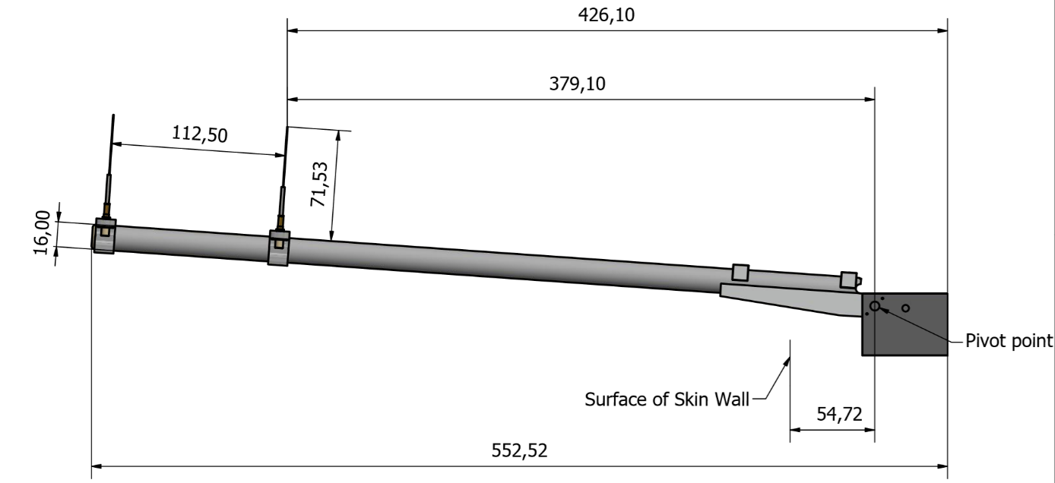
Figure 1: Boom dimensions (deployed) including hinge to skin distance (Mechanical workshop, Department of Physics, University of Oslo)
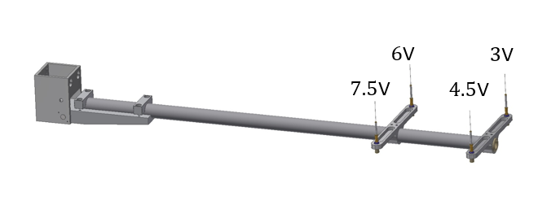
Figure 2: Voltages applied to the probes. (Mechanical workshop, Department of Physics, University of Oslo)
4.2 Calibration procedure
The m-NLP instrument works by attracting and collecting electrons to positively biased probes in the range typically 3-8V over the plasma potential.
During calibration, the instrument’s different channels are connected to a Source Measure Unit (SMU) and feeded with known currents covering the data range of the instrument. We used a Keithley 2635 SMU for the purpose.
By stepping the input current and doing a linear least square fit to the equation y = ax+b, we get the calibration constants a and b. At each data step we sample hundreds of values and do a simple median filtering to remove possible outliers.
The calibration constant a is actually calculated based on this stepping procedure, while the calibration constant b is a input independent offset caused by electronic components in the analog front end. The constant b is therefore measured separately by sampling the channel without any inputs connected.
From this procedure we get a calibration formula

$$x= \frac{y-b}{a}$$

where x is the actual current on the probe, y is the uncalibrated raw data (ADC value), b is the channel offset and a is the calibration constant.

4.3. Electron density estimation
The measurement technique is described in detail in [3, 4, 5, 6] and assumes probes with scale-sizes much smaller than the Debye length and operating in the electron saturation region. For ideal conditions, assuming $\frac{e\left(Vp+Vf \right)}{k_{B}T_{e}}>2$, non-drifting, collisionless and non-magnetized plasma plasma, the current $Ip$ collected to a m-NLP probe $p$ in the electron saturation region is given by [e.g. 4, 5]:

$$I_{p}=I_{th }K {\left(1+\frac{q\left(V_{p}+V_{f}\right)}{k_{B}T_{e}}\right)}^{β}$$

where $V_{p}$ is the potential applied to the probe, $V_{f}$the spacecraft potential with respect to the plasma potential, $q$ the electron charge, $T_{e}$ the electron temperature and $k_{B}$ Boltzmann's constant. The values $K$ and $β$ differ for different probe shapes such that $K=\frac{2}{√π}$and $β=.5$for cylindrical probes, and $K=1$and $β=1$ for a spherical probes. The current $I_{th}$ is given by $I_{th} = n_{e}qS \sqrt{k_{B}T_{e}/2πm_{e}}$ , where $S$ is the surface area of the probe, $m_{e}$ the electron mass and $n_{e}$ the electron density.

The electron density can then readily be calculated using $K=\frac{2}{√π}$and $β=.5$and the square of the currents obtained by several the m-NLP probes, irrespective of plasma temperature and changes in the potential [3, 4]. In the file, this estimate is referred to as “Ne_mnlp_unfilt”.

Recent studies however showed that that this method may suffer uncertainties, e.g. due to finite-length effects [5, 6]. In such cases, the equation above does not hold anymore, and the electron density is not independent of the floating potential, nor of the electron temperature. Based on numerical simulations taking into account finite-length effects on the m-NLP system, it has been shown that the actual $β$ was expected to take values between .5 and 1 [6]. Assessing such effects and uncertainties associated with the m-MLP system on Visions-2 are currently under investigation. For this reason, another estimate of the electron density is provided in the file as “Ne_mnlp_beta0pt8”, where $β=.8$ and $Te=3500 K$ where used.

- Variables:
Variable name | Units | Description/Comment
time | Seconds | Time of flight since launch, i.e. seconds since 20181207T110600 (UTC).
lat | Degree North | Geographic latitude
lon | Degree East | Geographic longitude
alt | Meter | Altitude of the payload
lat150km | Degree North | Geographic latitude of the payload projected along the magnetic field lines to an altitude of 150 km.
lat250km | Degree North | Geographic latitude of the payload projected along the magnetic field lines to an altitude of 250 km. 1
lon150km | Degree East | Geographic longitude of the payload projected along the magnetic field lines to an altitude of 150 km.1
Lon250km | Degree East | Geographic longitude of the payload projected along the magnetic field lines to an altitude of 250 km.1
I_mnlp | Ampere | Currents obtained by the four cylindrical Langmuir probes. The 1st-4th rows contain the currents obtained by the probes with bias voltages of 3V, 4.5V, 6V, and 7.5 V, respectively.
Ne_mnlp_unfilt | /m^3 | Unfiltered electron density obtained using all four multi-needle Langmuir probes and assuming beta=0.5. (See section 4.3)
Ne_mnlp_beta0pt8 | /m^3 | Electron density obtained using all four probes assuming Te=3500 K and \beta=0.8. (See section 4.3)
bias_voltage | Volt | Bias voltages applied to each of the probes
I_bias | - | Label for currents obtained by the four probes with applied voltages of 3V, 4.5V, 6V, and 7.5V

- Notice
Please contact PI and/or Andres Spicher (andres.spicher@fys.uio.no) before using for publications.

Acknowledgement
The 4-NLP experiment and the University of Oslo participation in the Grand Challenge Initiative Cusp rocket campaign were funded through the Research Council of Norway grant 275653. Thanks to Andres Spicher, Espen Trondsen, David Michael Bang-Hauge, and the Mechanical Workshop at the University of Oslo, Norway.

References:
1. Moen, J., Spicher, A., Rowland, D., Kletzing, C., & LaBelle, J. (2018). Grand challenge initiative‐cusp: Rockets to explore solar wind‐driven dynamics of the top side polar atmosphere. In SESS 2018 The State of Environmental Science in Svalbard (pp. 184– 204). Longyearbyen: Svalbard Integrated Arctic Earth Observing System.
2. Baker, D.N., Riesberg, L., Pankratz, C.K. et al. Magnetospheric Multiscale Instrument Suite Operations and Data System. Space Sci Rev 199, 545–575 (2016). https://doi.org/10.1007/s11214-014-0128-5
3. Bekkeng, T. A., K. S. Jacobsen, J. K. Bekkeng, A. Pedersen, T. Lindem, J.‐P. Lebreton, and J. I. Moen (2010), Design of a multi‐needle Langmuir probe system, Meas. Sci. Technol., 21, 085,903, doi:10.1088/0957‐0233/21/8/085903
4. Jacobsen, K. S., Pedersen, A., Moen, J. I., & Bekkeng, T. A. (2010), A new Langmuir probe concept for rapid sampling of space plasma electron density. Measurement Science and Technology, 21(8), https://doi.org/10.1088/0957‐0233/21/8/085902
5. H Hoang et al. (2018), A study of data analysis techniques for the multi-needle Langmuir probe, Measurement Science and Technology, 29(6), p. 065906. doi:10.1088/1361-6501/aab948.
6. Marholm, S., and Marchand, R. (2020), Finite-length effects on cylindrical Langmuir probes, Phys. Rev. Research 2, p. 023016. doi: 10.1103/PhysRevResearch.2.023016.

Webpages:
https://www.grandchallenge.no/
https://spdf.gsfc.nasa.gov/
https://archive.norstore.no/

http://wiki.esipfed.org/index.php/Attribute_Convention_for_Data_Discovery_1-3 (01.10.2019)
https://spdf.gsfc.nasa.gov/istp_guide/gattributes.html (12.10.2019)
http://cfconventions.org/Data/cf-conventions/cf-conventions-1.7/cf-conventions.html (29.09.2020)

https://www.grandchallenge.no/
https://spdf.gsfc.nasa.gov/
https://spdf.gsfc.nasa.gov/istp_guide/gattributes.html (12.10.2019)
https://archive.norstore.no/
Projection computed by T. Takahashi using IDL geopack version 10.5 (toru.takahashi@fys.uio.no)

